Garbage image classifier using ResNet-50
Bagus Dwi Santoso¹, Nur Nafi’iyah²
^{1.2,} Informatics Engineering, Faculty of Engineering
Universitas Islam Lamongan
E-mail: bagusdwi@unisla.ac.id¹, mynaff@unisla.ac.id²

A R T I C L E I N F O |  | ABSTRACT
History of the article:  Received  Revised  Accepted |  | The escalating global waste production has become increasingly concerning each day, underscoring the urgent need for effective waste sorting solutions. This research aims to build an image classification model to address this issue. We propose a deep learning model to classify 12 types of garbage based on pretrained ResNet-50 architecture, additional fully connected layers applying regularization techniques, including batch normalization and dropout were added before the output layer. Six experiments were conducted using the Adadelta and Adamax optimizers with varying learning rates to determine the most optimal training parameter configuration for the proposed model. Results shows that Adamax performed best with smaller lr (0.01 and 0.001) achieving train accuracy = 98.49% and 98.58% with val_accuracy = 93.10% and 93.44%. Adadelta showed better performance with a larger learning rate (0.1) having accuracy = 98.13%. The confusion matrix revealed a predominant diagonal trend across all experiments. Nevertheless, each experiment showed a tendency for misclassification in the metal, plastic, and white-glass classes.
Keywords:
Garbage classification
Deep learning
ResNet-50
Adadelta
Adamax

Correspondece:
Telepon: +62 857 8213 8559
E-mail: bagusdwi@unisla.ac.id

INTRODUCTION
The escalating growth of the global population and consumption stands as two primary factors contributing to the serious issue of increasing waste production worldwide. The world generated approximately 20 billion tons of waste, equivalent to an average of 2.63 tons of waste per person per year and is estimated to skyrocket to reach 46 billion tons by the year 2050 (Maalouf & Mavropoulos, 2023). Study (Qonitan et al., 2021) revealed that the average municipal solid waste (MSW) generation in 10 big cities in Indonesia is 0.69KG/capita-day. This becomes more concerning by a lack of awareness and the community's difficulties in sorting and reducing waste (Irmawartini et al., 2023).
The technological advancements in recent years have opened new opportunities in waste management, recent studies have successfully built a hardware solution for garbage classification utilizing deep learning as its core (Gupta et al., 2022; Wang et al., 2021), creating a potentially easier garbage sorting solution. The popular techniques used in garbage image classification are machine learning and deep learning (Xia et al., 2022), this includes KNN (Dubey et al., 2020), SVM, Random Forest, Decision Tree, and CNN (Sami et al., 2020). Previous studies revealed that deep learning techniques provide a more accurate results in contrast of machine learning techniques.
One of the approaches to build advanced deep learning model is by utilizing transfer learning, the reuse of a pre-trained model from one task to improve optimization in a related task, especially when dealing with a smaller new dataset (Hussain et al., 2019). (Cao & Xiang, 2020) have applied transfer learning-based CNN for classifying garbage, they use one of transfer learning architecture named InceptionV3 and achieved accuracy of 99.3% and test accuracy of 93.2%. In (Meng & Chu, 2020), they experimented garbage image classification utilizing different transfer learning architecture, this study shows ResNet-50 is able to give accurate classification having accuracy = 95.35%. (Ahmed et al., 2023) obtained great accuracy for garbage image classification using DenseNet69, MobileNetV2, and ResNet50V2 with accuracy of 94.4%, 97.6%, and 98.95% respectively.
Regularization techniques such as Batch Normalization and Dropout can be employed to improve training efficiency. Batch Normalization offers key advantages such as stabilizing learning, reducing required training epochs for convergence, facilitating the use of higher learning rates, and decreasing sensitivity to initialization (Kocaman et al., 2021). Dropout layers randomly deactivates specific neurons during training, diminishing the co-adaptation of features and mitigating overfitting. The primary objective of dropout is to elevate the generalization capabilities of neural networks by creating an ensemble of sub-networks that share parameters and are trained on distinct subsets of the data (Jabir & Falih, 2021).
This study aims to build a garbage image classifier model using pretrained CNN and explore the efficient training parameter. In this study, ResNet-50 architecture will be used as the basis of the classification model. Different optimizers and learning rates will be applied during training in order to determine the optimal parameter configuration for the proposed model.

RESEARCH METHODS
- Research Steps
There are several steps in order to reach the expected goal is shown in Figure 1. These steps include selecting dataset, balancing dataset, splitting dataset into train and validation, training, and evaluation.
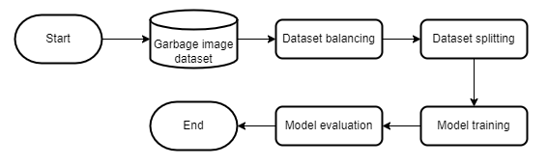
Figure 1. Research steps
The first stage involves downloading the waste image dataset obtained from the Kaggle platform. Upon acquiring the dataset, we perform dataset balancing by employing a down-sampling method, down-sampling method is a way to deal with the unbalance in the training dataset by reducing the number of samples from the over-represented classes (Steiniger et al., 2020). The purpose of this step is to ensure an even distribution of data, an evenly distributed dataset is required to improve overall model accuracy (Chen et al., 2017).
After successfully balancing the dataset, we then split the dataset into train and validation with ratio of 0,8:0,2. This practice is crucial as it enables the model to learn from a representative portion of the data and subsequently assess its performance on unseen data. Moreover, data splitting serves to prevent overfitting, a situation where the model memorizes the training data but struggles to generalize to new data (Nguyen et al., 2021).
Subsequently, we train the model using the ResNet-50 architecture. We opt to employ multiple optimizers with varying learning rates to train the model. The utilization of different optimizers and learning rates allows us to explore various training configurations and select the one that yields the best results.
- Dataset description
The dataset, curated by (Mohamed, n.d.), comprises 15,150 image samples belonging to 12 distinct household waste classes, namely: battery, biological, brown-glass, cardboard, clothes, green-glass, metal, paper, plastic, shoes, trash, and white-glass. Figure 2 displays sample images for each class within the dataset.
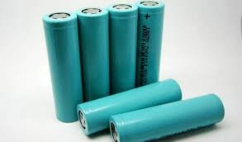  (a) | 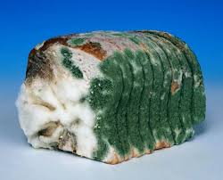  (b) | 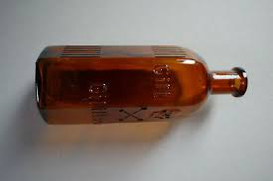  (c)
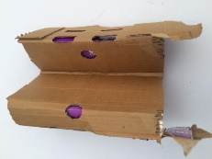  (d) | 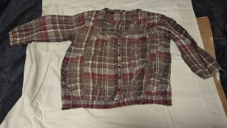  (e) |   (f)
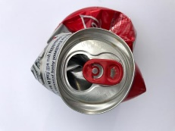  (g) | 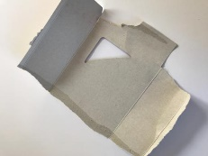  (h) | 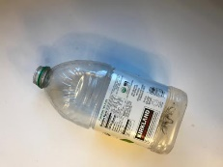  (i)
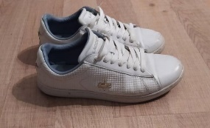  (j) | 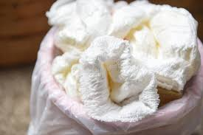  (k) |   (l)
Figure 2. Image samples of (a) battery, (b) biological, (c) brown-glass, (d) cardboard, (e) clothes, (f) green-glass, (g) metal, (h) paper, (i) plastic, (j) shoes, (k) trash, (l) white-glass.

After collecting and analyzing the entire dataset, we identified an imbalance in the class distribution, necessitating data balancing using a down-sampling method. This involved equalizing the number of samples for all classes, aligning them with the class with the fewest instances, namely brown-glass which had 607 images. The balanced dataset was then split into training and validation data with an 80:20 ratio as detailed in Table 1.
Table 1. Data distribution after down-sampling
No. | Class | Train | Val | Total
1 | battery | 485 | 122 | 607
2 | biological | 485 | 122 | 607
3 | brown-glass | 485 | 122 | 607
4 | cardboard | 485 | 122 | 607
5 | clothes | 485 | 122 | 607
6 | green-glass | 485 | 122 | 607
7 | metal | 485 | 122 | 607
8 | paper | 485 | 122 | 607
9 | plastic | 485 | 122 | 607
10 | shoes | 485 | 122 | 607
11 | trash | 485 | 122 | 607
12 | white-glass | 485 | 122 | 607
Total |  | 5820 | 1464 | 7284
- Convolutional Neural Network
Convolutional Neural Network (CNN) is a specialized multilayer neural network crafted for recognizing shapes in image processing tasks (Bircanoglu et al., 2018). The core of CNN is the convolutional layer. This layer executes convolution, a linear operation involving weight multiplication with the input. Specifically tailored for two-dimensional input, it conducts this operation between the input array and a set of weights known as filters or kernels (Brownlee, 2019).
- Modified ResNet-50
ResNet-50 (Residual Network) is a variaion of the Residual Network (ResNet) which has 50 layers that has undergone training on a dataset of at least one million images from the ImageNet database (Victor Ikechukwu et al., 2021). ResNet effectively addresses common challenges in deep neural networks, such as vanishing gradient and degradation, by employing skip connections or shortcuts (Sarwinda et al., 2021). These connections facilitate learning the residual mapping between input and output layers. Figure 3 illustrates the layer arrangement in the ResNet-50 architecture (Islam et al., 2022).
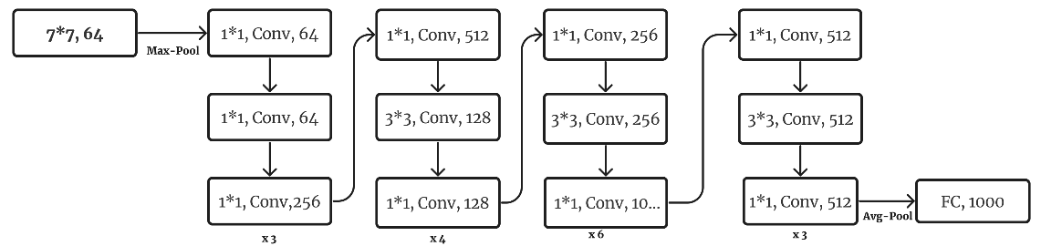
Figure 3. ResNet-50 architecture

We add modification of fully connected layers after the pretrained model output. First step we define the input layer with input size of 224×224×3 followed by the ResNet-50 model, here we load the weights from ImageNet and setting it untrainable by freezing all the layers to ensure the loaded weights remain fixed. Finally, we construct the complete model by stacking additional layers on top of the frozen base model. The added layers include a Flatten layer to convert the 3D output to a 1D vector, BatchNormalization layers for normalization, Dense layers with, Dropout layers to prevent overfitting, and a final Dense layer with a softmax activation function containing 12 units. The complete model modifications can be seen in Figure 4.
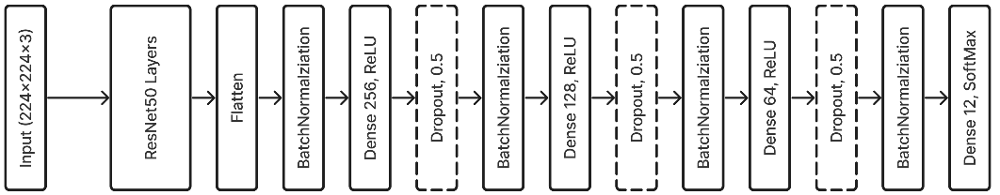
Figure 4. Proposed model’s architecture
- Performance Measure
Model evaluation process is conducted on the validation subset using various evaluation metrics, including accuracy, which is the ratio of correctly classified results to the total number of all results. In other words, accuracy measures how many predictions the model makes correctly (Ahmed et al., 2023). Accuracy can be defined in Equation (1).
$\text{Accuracy }= \frac{Correct Predictions}{All Predictions}$ (1)
In the evaluation of the performance of a multi-class classification model, relying solely on accuracy as a metric is not sufficient. The confusion matrix stands as an essential tool, offering a thorough evaluation of the model's effectiveness. Within this matrix lie key metrics: True Positives (TP), True Negatives (TN), False Positives (FP), and False Negatives (FN). TP and TN signify correct predictions, whereas FP and FN denote erroneous ones. Therefore, the confusion matrix offers a detailed overview of the model's performance in predicting each class (Koklu & Ozkan, 2020). Multi-class classification confusion matrix can be represented in Table 2.
Table 2. Multiclass confusion matrix
 |  | Predicted
 |  | C₁ | C₂ | C₃ | … | C_{n}
Actual | C₁ | T₁ | F₁₂ | F₁₃ | … | F_{1n}
Actual | C₂ | F₂₁ | T₂ | F₂₃ | … | F_{2n}
Actual | C₃ | F₃₁ | F₃₂ | T₃ | … | F_{3n}
Actual | … | … | … | … | … | …
Actual | C_{n} | F_{n1} | F_{n2} | F_{n3} | … | T_{n}
- Experimental Setup
We aim to achieve the best training performance, 6 training experiments were conducted as detailed in Table 3. We utilized the Adadelta optimizer, which, as demonstrated in the study by (Meng & Chu, 2020) provided the best accuracy, and Adamax, known for good performance according to (Yang et al., 2022). Both optimizers were then experimented with varying LRs.
Table 3. Training setup
No. | Optimizer | LR | Num of Epochs
1 | Adadelta | 0.1 | 100
2 | Adadelta | 0.01 | 100
3 | Adadelta | 0.001 | 100
4 | Adamax | 0.1 | 100
5 | Adamax | 0.01 | 100
6 | Adamax | 0.001 | 100

RESULTS AND DISCUSSION
We successfully compiled the proposed model, the model is built sequentially with modifications including the pretrained ResNet-50 layer that has been frozen across all its layers. Following this, a Flatten layer and BatchNormalization are applied before passing the data through three hidden Dense layers, each having 256, 128, and 64 units, respectively. After every Dense layer, there follows a dropout layer and batch normalization, preceding the transmission of data to output Dense layer comprising 12 units. The detailed architecture of this model is depicted in the model summary shown in Figure 5.
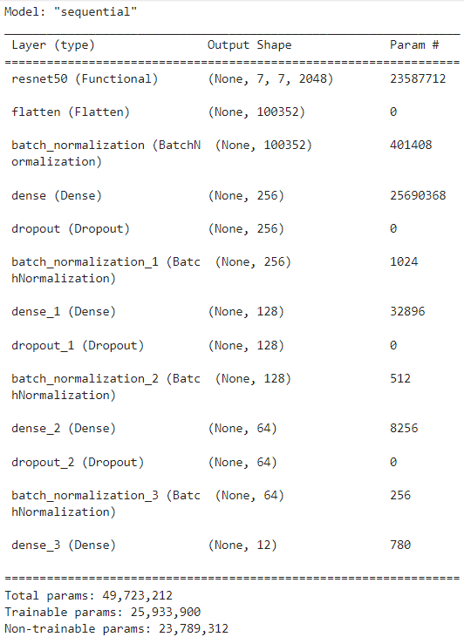
Figure 5. Model summary
After defining the model, we then conducted 6 training experiments with different optimizers and learning rates, it is evident that the proposed model achieves the best accuracy using the Adamax optimizer with a learning rate of 0.001. The overall results of the training experiments are summarized in Table 4. In order to gain a more detailed understanding of how the model behaves during training, we can examine the plots of training accuracy and validation accuracy in the training history plots in Figure 6 (a), (b), (c), and (d), as well as the Confusion Matrix in Figure 7 (a), (b), (c), and (d). These gives a more comprehensive description of correct and incorrect classification outcomes for each individual class.
Table 4. Model performance
No. | Optimizer | LR | Accuracy (%) | Val Accuracy (%)
1 | Adadelta | 0.1 | 98.13 | 93.85
2 | Adadelta | 0.01 | 88.09 | 92.35
3 | Adadelta | 0.001 | 43.51 | 82.65
4 | Adamax | 0.1 | 97.65 | 92.96
5 | Adamax | 0.01 | 98.49 | 93.10
6 | Adamax | 0.001 | 98.58 | 93.44

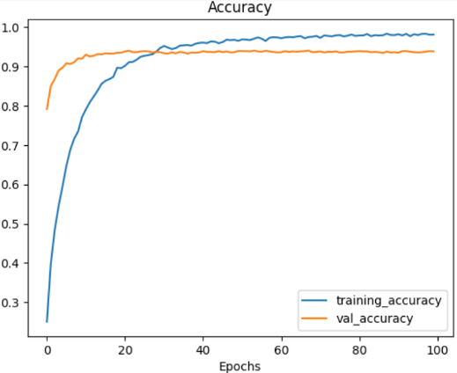  (a) | 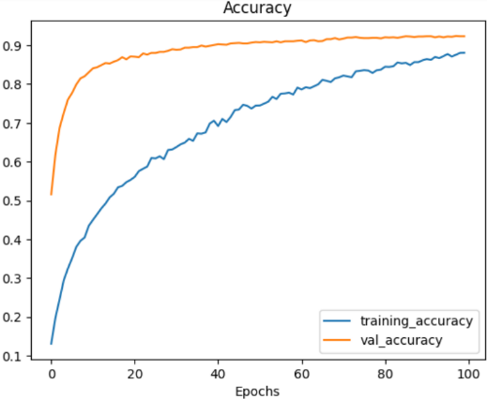  (b)
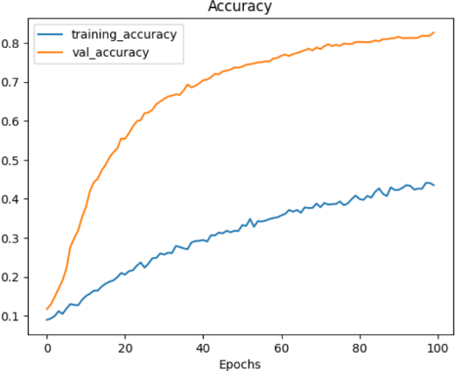  (c) | 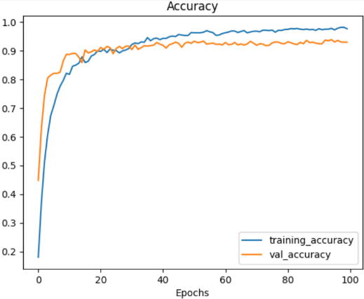  (d)
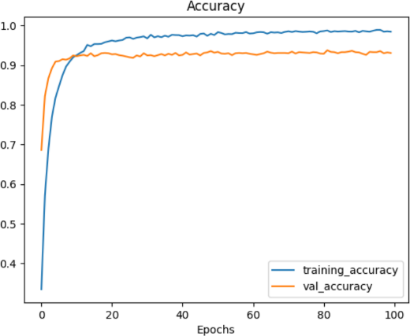  (e) | 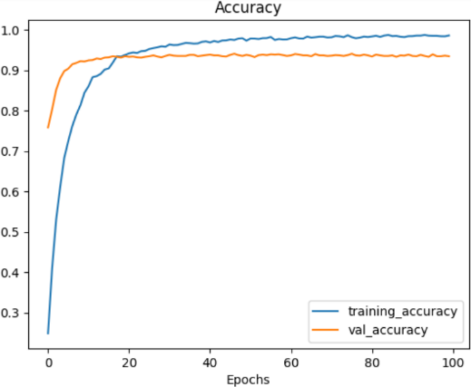  (f)
Figure 6. Training history plots for (a) the first training, (b) the second training, (c) the third training, (d) the fourth training, (e) the fifth training, (f) the sixth training.
In Figure 6 (a) and Figure 6 (d) both use LR of 0.1 achieving high training accuracies of 98.13% and 97.65%, respectively, with validation accuracies above 92%. This suggests that a learning rate of 0.1 is effective for both optimizers. In Figure 6 (e) and (f) Adamax with LR of 0.01 and 0.001, achieve the highest training accuracies of 98.49% and 98.58% respectively, with validation accuracies surpassing 93%, indicating that Adamax performs exceptionally well at lower LR.
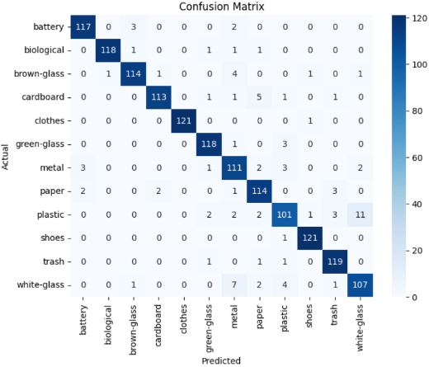  (a) | 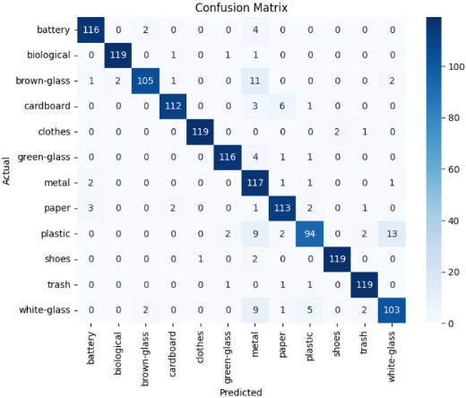  (b)
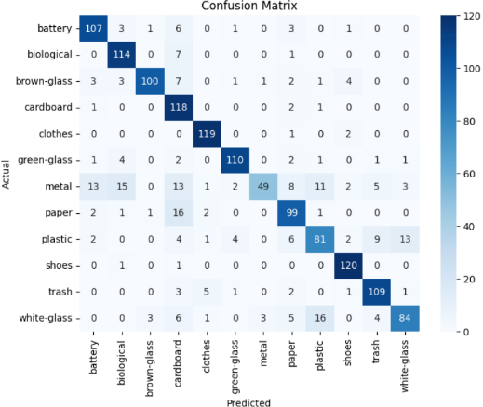  (c) | 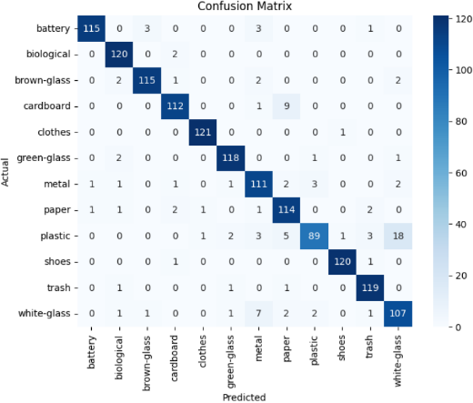  (d)
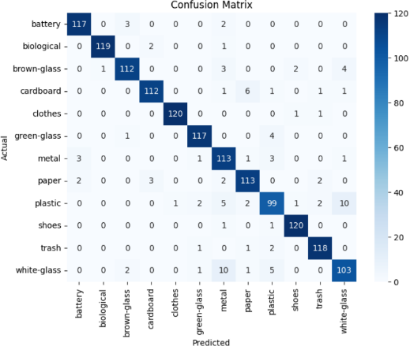  (e) | 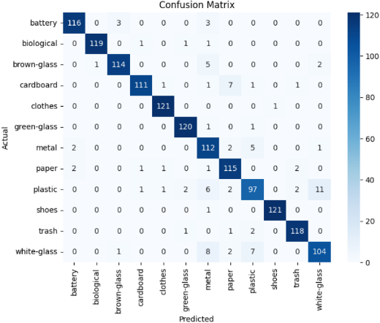  (f)
Figure 7. Confusion matrices of (a) the first training, (b) the second training, (c) the third training, (d) the fourth training, (e) the fifth training, (f) the sixth training.
Figure 7 (a), (b), (c), and (d) illustrate the confusion matrices for each of six training experiments, providing a deeper understanding of the correctness of the proposed model in classifying garbage images. Specifically, we observe a predominant diagonal trend in all training experiments, indicating a high level of correct classification. However, values outside the diagonal signify instances of misclassification. Figure 7 (a) and (b), the model appears to perform well with few misclassifications, with misclassifications occurring in the plastic class. Figure 7 (c) and (d) exhibit clearer off-diagonal elements, indicating higher misclassification rates in the metal, plastic, and white glass classes. Figure 7 (e) and (f) demonstrate a balance between correct and misclassifications, with minor errors in the plastic class.

CONCLUSIONS AND RECOMMENDATIONS
We propose a waste classification model using pretrained ResNet-50 with modifications to the ResNet-50 model output and conduct training experiments using the Adamax and Adadelta optimizers with varying learning rates. The results of the training experiments indicate that the model achieves optimal accuracy when configured with the Adamax optimizer and LR = 0.001. Adadelta and Adamax both perform well with LR of 0.1. while smaller learning rates, such as 0.01 and 0.001, enhance model performance under the Adamax optimizer.
Based on the analysis of the confusion matrix, it can be concluded that the model tends to perform better in identifying some classes compared to others. Although the overall model performance shows high classification rates, special attention needs to be given to the metal, plastic, and white glass classes, where there is a higher rate of misclassification. One solution to this issue is the addition of image data for these classes, which can be achieved by collecting new data for training or augmenting data using data augmentation techniques.
References
Ahmed, M. I. B., Alotaibi, R. B., Al-Qahtani, R. A., Al-Qahtani, R. S., Al-Hetela, S. S., Al-Matar, K. A., Al-Saqer, N. K., Rahman, A., Saraireh, L., Youldash, M., & Krishnasamy, G. (2023). Deep Learning Approach to Recyclable Products Classification: Towards Sustainable Waste Management.
Bircanoglu, C., Atay, M., Beser, F., Genc, O., & Kizrak, M. A. (2018). RecycleNet: Intelligent Waste Sorting Using Deep Neural Networks. 2018 Innovations in Intelligent Systems and Applications (INISTA), 1–7. https://doi.org/10.1109/INISTA.2018.8466276
Brownlee, J. (2019). Deep Learning for Computer Vision (v1.4).
Cao, L., & Xiang, W. (2020). Application of Convolutional Neural Network Based on Transfer Learning for Garbage Classification. 2020 IEEE 5th Information Technology and Mechatronics Engineering Conference (ITOEC), 1032–1036. https://doi.org/10.1109/ITOEC49072.2020.9141699
Chen, H., Xiong, F., Wu, D., Zheng, L., Peng, A., Hong, X., Tang, B., Lu, H., Shi, H., & Zheng, H. (2017). Assessing impacts of data volume and data set balance in using deep learning approach to human activity recognition. 2017 IEEE International Conference on Bioinformatics and Biomedicine (BIBM), 1160–1165. https://doi.org/10.1109/BIBM.2017.8217821
Dubey, S., Singh, P., Yadav, P., & Singh, K. K. (2020). Household Waste Management System Using IoT and Machine Learning. Procedia Computer Science, 167, 1950–1959. https://doi.org/10.1016/j.procs.2020.03.222
Gupta, T., Joshi, R., Mukhopadhyay, D., Sachdeva, K., Jain, N., Virmani, D., & Garcia-Hernandez, L. (2022). A deep learning approach based hardware solution to categorise garbage in environment. Complex & Intelligent Systems, 8(2), 1129–1152. https://doi.org/10.1007/s40747-021-00529-0
Hussain, M., Bird, J. J., & Faria, D. R. (2019). A Study on CNN Transfer Learning for Image Classification. In A. Lotfi, H. Bouchachia, A. Gegov, C. Langensiepen, & M. McGinnity (Eds.), Advances in Computational Intelligence Systems (Vol. 840, pp. 191–202). Springer International Publishing. https://doi.org/10.1007/978-3-319-97982-3_16
Irmawartini, I., Mulyati, S. S., & Pujiono, P. (2023). Pengelolaan Sampah dari Hulu ke Hilir di Kota Bandung. Jurnal Kesehatan Lingkungan Indonesia, 22(2), 229–236. https://doi.org/10.14710/jkli.22.2.229-236
Islam, W., Jones, M., Faiz, R., Sadeghipour, N., Qiu, Y., & Zheng, B. (2022). Improving Performance of Breast Lesion Classification Using a ResNet50 Model Optimized with a Novel Attention Mechanism. Tomography, 8(5), 2411–2425. https://doi.org/10.3390/tomography8050200
Jabir, B., & Falih, N. (2021). Dropout, a basic and effective regularization method for a deep learning model: A case study. Indonesian Journal of Electrical Engineering and Computer Science, 24(2), 1009. https://doi.org/10.11591/ijeecs.v24.i2.pp1009-1016
Kocaman, V., Shir, O. M., & Back, T. (2021). Improving Model Accuracy for Imbalanced Image Classification Tasks by Adding a Final Batch Normalization Layer: An Empirical Study. 2020 25th International Conference on Pattern Recognition (ICPR), 10404–10411. https://doi.org/10.1109/ICPR48806.2021.9412907
Koklu, M., & Ozkan, I. A. (2020). Multiclass classification of dry beans using computer vision and machine learning techniques. Computers and Electronics in Agriculture, 174, 105507. https://doi.org/10.1016/j.compag.2020.105507
Maalouf, A., & Mavropoulos, A. (2023). Re-assessing global municipal solid waste generation. Waste Management & Research: The Journal for a Sustainable Circular Economy, 41(4), 936–947. https://doi.org/10.1177/0734242X221074116
Meng, S., & Chu, W.-T. (2020). A Study of Garbage Classification with Convolutional Neural Networks. 2020 Indo – Taiwan 2nd International Conference on Computing, Analytics and Networks (Indo-Taiwan ICAN), 152–157. https://doi.org/10.1109/Indo-TaiwanICAN48429.2020.9181311
Mohamed, M. (n.d.). Garbage Classification (12 classes) [dataset]. https://www.kaggle.com/datasets/mostafaabla/garbage-classification.
Nguyen, Q. H., Ly, H.-B., Ho, L. S., Al-Ansari, N., Le, H. V., Tran, V. Q., Prakash, I., & Pham, B. T. (2021). Influence of Data Splitting on Performance of Machine Learning Models in Prediction of Shear Strength of Soil. Mathematical Problems in Engineering, 2021, 1–15. https://doi.org/10.1155/2021/4832864
Qonitan, F. D., Wayan Koko Suryawan, I., & Rahman, A. (2021). Overview of Municipal Solid Waste Generation and Energy Utilization Potential in Major Cities of Indonesia. Journal of Physics: Conference Series, 1858(1), 012064. https://doi.org/10.1088/1742-6596/1858/1/012064
Sami, K. N., Amin, Z. M. A., & Hassan, R. (2020). Waste Management Using Machine Learning and Deep Learning Algorithms. International Journal on Perceptive and Cognitive Computing, 6(2), 97–106. https://doi.org/10.31436/ijpcc.v6i2.165
Sarwinda, D., Paradisa, R. H., Bustamam, A., & Anggia, P. (2021). Deep Learning in Image Classification using Residual Network (ResNet) Variants for Detection of Colorectal Cancer. Procedia Computer Science, 179, 423–431. https://doi.org/10.1016/j.procs.2021.01.025
Steiniger, Y., Stoppe, J., Meisen, T., & Kraus, D. (2020). Dealing With Highly Unbalanced Sidescan Sonar Image Datasets for Deep Learning Classification Tasks. Global Oceans 2020: Singapore – U.S. Gulf Coast, 1–7. https://doi.org/10.1109/IEEECONF38699.2020.9389373
Victor Ikechukwu, A., Murali, S., Deepu, R., & Shivamurthy, R. C. (2021). ResNet-50 vs VGG-19 vs training from scratch: A comparative analysis of the segmentation and classification of Pneumonia from chest X-ray images. Global Transitions Proceedings, 2(2), 375–381. https://doi.org/10.1016/j.gltp.2021.08.027
Wang, C., Qin, J., Qu, C., Ran, X., Liu, C., & Chen, B. (2021). A smart municipal waste management system based on deep-learning and Internet of Things. Waste Management, 135, 20–29. https://doi.org/10.1016/j.wasman.2021.08.028
Xia, W., Jiang, Y., Chen, X., & Zhao, R. (2022). Application of machine learning algorithms in municipal solid waste management: A mini review. Waste Management & Research: The Journal for a Sustainable Circular Economy, 40(6), 609–624. https://doi.org/10.1177/0734242X211033716
Yang, Z., Xia, Z., Yang, G., & Lv, Y. (2022). A Garbage Classification Method Based on a Small Convolution Neural Network. Sustainability, 14(22), 14735. https://doi.org/10.3390/su142214735

