Optimizing Clustering of Indonesian Text Data Using Particle Swarm Optimization Algorithm: A Case Study of the Qur'an Translation

M. Didik R. Wahyudi ^{1,*}, Agung Fatwanto ²
¹ Department of Informatic Engineering, Faculty of Science and Technology, Islamic State University of Sunan Kalijaga Yogyakarta
E-mail: ¹ m.didik@uin-suka.ac.id*; ² agung.fatwanto@uin-suka.ac.id

A R T I C L E I N F O |  | ABSTRACT
History of the article:  Received January 1, 2019  Revised January 21, 2019  Accepted January 12, 2019 |  | The grouping of the verses of the Qur'an is made to make it easier to understand. Grouping can be done with an algorithm based on similar patterns in a collection of text or documents. Clustering is a method of grouping an object using a specific algorithm, one of which is K-Means clustering. The clustering process is done by calculating a word weight. The clustering results are often less than optimal because of the random selection of centroids. Therefore, the Particle Swarm Optimization (PSO) algorithm will be used in this study. The PSO algorithm will produce a centroid value that will be used for clustering with K-Means. Another model of PSO is the hybrid PSO. This hybrid PSO algorithm first executes the K-means algorithm once. In this case the K-Means clustering is stopped when (1) the maximum number of iterations is exceeded, or when (2) the mean change in the centroid vector is less than 0.0001.  The clustering results of the three models show that the lowest Sum of Squared Error (SSE) value of 1032.19 is generated by the K-Means algorithm. The highest Silhouette value is generated from the PSO hybrid algorithm of 0.258. The lowest quantization value of 0.00947 was generated from the PSO hybrid algorithm. The results of clustering were also evaluated with a confusion matrix which resulted in a value of 81,7% for clustering with K-Means, K-Means with PSO of 82,5% and the combination of K-Means with PSO hybrid resulted in a value of 91,1, which is the highest confusion matrix value of the three clustering models.
Keywords:
Text_mining
Clustering
K-Means
Particle_Swarm_Optimization
Al_Qur’an_Translation

Correspondece:
Telepon: +62 81215526339
E-mail : m.didik@uin-suka.ac.id

INTRODUCTION
The Qur'an has a unique structure, one of which is divided into 30 sections called juz. Each juz is divided into several different bows in each surah depending on the number of verses in the surah and the short length of each verse (Khotimah, 2014). The grouping aims to make memorizing, studying, and studying the Qur'an easier Each letter can contain various themes, and specific themes can be in several letters.
Text grouping in text mining can determine the relationship/relevance between verses, one of which is clustering. Clustering is a part of document classification that divides a collection of texts into several subsets called clusters. Each cluster's text has a more significant similarity than those in different clusters. Clustering is useful for organizing documents to improve information retrieval and support browsing (Aggarwal and Zhai, 2013).
The determination of the centroid influences the quality of the clustering results. In K-Means, the resolution of clustering is made randomly. This can result in less than optimal clustering results. Therefore, it is necessary to optimize the centroid so that the resulting clustering is more optimal.
The quality of clustering results with K-Means can be improved by using Particle Swarm Optimization (PSO). With PSO, the K-Means centroid was determined by the PSO and PSO hybrid methods. The combination of PSO with K-Means gives better clustering results when compared to clustering with K-Means (Van Der Merwe and Engelbrecht, 2003).
Particle Swarm Optimization (PSO) is used as a feature selection algorithm. This algorithm uses Term Frequency-Inverse Document Frequency (TF-IDF) is a function to evaluate each text feature at the document level (Abualigah, Khader and Hanandeh, 2018)
To overcome the convergence problem of the fuzzy c-means clustering algorithm based on PSO, which is sensitive to noise and less effective when handling data sets with larger dimensions, a Fuzzy C-Means (FCM) clustering method based on the enhanced PSO algorithm is proposed. This approach distributes membership based on the distance between the sample center and the cluster so that membership satisfies the FCM constraint. Then optimization is carried out so that the optimal particles are guided to cover the group effectively. Experimental results show the proposed method significantly enhances the effect of PSO-based FCM clustering encoded in membership (Niu and Huang, 2011).
The Image-Based Medicinal Plant Identification System created in 2014 states that the PSO method is used to overcome the weaknesses of the traditional clustering method, namely the selection of the initial cluster center and local solutions. This study showed that the PSO method improved the performance of the k-means clustering method in the identification process of medicinal plants (Bisilisin, Herdiyeni and Silalahi, 2017).
The study entitled Optimization of K-Means Clustering for Identification of Infectious Diseases Endemic Areas with the Particle Swarm Optimization Algorithm in the city of Semarang in 2018 showed that the use of optimization in identifying infectious disease-endemic areas by combining the K-Means clustering algorithm with particle swarm optimization (PSO) have better performance (Rustam, Santoso and Supriyanto, 2018)
The research entitled Combining Particle Swarm Optimization based on Feature Selection and Bagging Technique for Software Defect Prediction in 2013 discussed the combination of PSO optimization and bagging techniques to increase the accuracy of software defect prediction. PSO is applied to handle feature selection, and the bagging method deals with class imbalance problems (Wahono and Suryana, 2013)

RESEARCH METHODS
The research steps to be carried out are as follows: First, the conversion of the translated text of the Koran in Indonesian into the required dataset format and preprocessing of the dataset. Second, clustering the Indonesian translation of the Al-Qur'an dataset. Clustering was carried out several times to obtain the best cluster results. They are testing the clustering results done on each to find the best cluster results. They were third, clustering with PSO and PSO hybrid with the best number of clusters generated from the previous process. Fourth, an analysis of the effects of three clustering models (K-Means clustering, K-Means, and PSO, as well as the K-Means algorithm with PSO hybrid) was produced. The research steps are shown in Figure 1.
Search for the best K number based on the Silhouette Coefficient value
Clustering process with K-Means++, K-Means - PSO, and K-Means - PSO Hybrid

Analysis of the results of 3 clustering models
Data Set Formation and Preprocessing

Figure 1: Research Steps

RESULTS AND DISCUSSION
The grouping of the Qur'an translation documents can be done in various ways, such as the similarity between the translations of the Qur'anic verses (R.Wahyudi, 2019) and K-means clustering combined with the normalization of the TF-IDF algorithm (Wahyudi, 2020). This study performs distance-based clustering of the translation of the Qur'an using K-Means clustering. K-means clustering is an algorithm for grouping data based on the proximity of the distance to the main point or centroid to produce specific data groups (Kaur, 2017). Centroids are determined randomly. This random centroid determination model is a weakness of k-means clustering. To overcome these weaknesses, particle swarm optimization (Tan, 2015) with a fitness function silhouette coefficient is used to determine the initial centroid point. PSO is a population search algorithm based on simulations of the social behavior of bees or schools of fish. This algorithm was initially intended to simulate the folk bird's graceful and unpredictable choreography graphically. PSO is a straightforward optimization technique to apply and modify several parameters (Basari et al., 2013).
Preprocessing in this study includes lemmatizing, and stop words are not deleted. The process of lemmatizing is returning a comment to the root word. In this study, the stop word is not removed so that the actual meaning of the translated sentence of the Qur'an does not change to the opposite meaning. Next, the weight of each document's word will be determined using the TF-IDF algorithm. TF-IDF is a statistical measurement to measure a term’s importance in a document. In the calculations carried out, the weight will be calculated based on the frequency of occurrence without considering the position of the word in the text, its semantics, and its event with other terms in the document.

Finding the best K number in the group
The K-Means method groups data into several groups, where data in one group have the same characteristics and have different parts from data in other groups (Agusta, 2007). The K-Means method cluster results depend on the group center’s initial value. Giving different initial values ​​can produce other groups (B. Santosa, 2007), so to determine the best number of k, repeated simulations of the clustering process with the K-Means algorithm were performed ten times and model testing by calculating the silhouette coefficients generated by each clustering process. Silhouette coefficient testing tests the model to determine how close the relationship between objects in a cluster is and how far apart a set is from another group. The silhouette coefficient method combines two methods, namely the cohesion method, which measures how close the relationship between objects in a cluster is, and the separation method, which measures how far one set is from another. The silhouette coefficient calculation stages are shown in equations 1 to 4:

- Calculate the average distance i centroid point to all objects in one cluster.
𝛼(𝑖)=1 |A| ∑𝑗 ∈𝐴,𝑗≠𝑖 𝐶 𝑑(𝑖,𝑗), (1)
Where j is the object in cluster A and d(i, j) is the distance of object i to j.

- Calculate the average distance i centroid point to all other cluster objects, then take the smallest value.
𝑑(𝑖,𝐶) = 1 |A| ∑𝑗 ∈ 𝐶 𝑑(𝑖,𝑗), (2)

Where d(i,C) is the distance of object i to other cluster objects
𝑏(𝑖) = min𝐶 ≠ 𝐴 𝑑(𝑖,𝐶), (3)

- Calculate the silhouette coefficient for each centroid
𝑠(𝑖) = b(i)-a(i) max (a(i),b(i)), (4)

The average value of the silhouette coefficient or s(i) shows how precisely the data is grouped. The best k number search program code is shown in Figure 2.

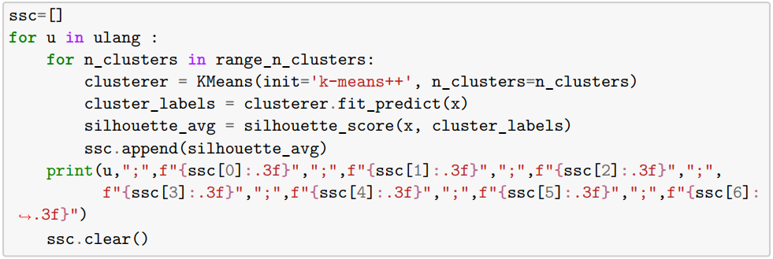

Figure 2: Program code to find the best number of K in clustering
From the code in Figure 2, the silhouette coefficient value is generated from 10 simulations of the clustering process as shown in table 1. From table 1 it can be concluded that from 10 simulations of the search for the best number of clusters in the translation of the Qur'an, it resulted that 90% of the number of clusters The best is 4. And only one simulation shows that the best number of clusters is 9. Therefore, the number of clusters will be used in this study is 4 clusters.
Table 1: Silhouette coefficients resulting from the search for the best K
Simulation to | Number of Clusters
Simulation to | 3 | 4 | 5 | 6 | 7 | 8 | 9
1 | 0.255 | 0.269 | 0.245 | 0.234 | 0.196 | 0.261 | 0.251
2 | 0.255 | 0.269 | 0.265 | 0.235 | 0.242 | 0.212 | 0.251
3 | 0.255 | 0.269 | 0.265 | 0.234 | 0.242 | 0.261 | 0.231
4 | 0.255 | 0.263 | 0.264 | 0.235 | 0.242 | 0.261 | 0.268
5 | 0.255 | 0.270 | 0.265 | 0.234 | 0.242 | 0.212 | 0.262
6 | 0.255 | 0.269 | 0.265 | 0.235 | 0.242 | 0.212 | 0.223
7 | 0.255 | 0.269 | 0.265 | 0.235 | 0.243 | 0.261 | 0.268
8 | 0.254 | 0.269 | 0.265 | 0.235 | 0.243 | 0.212 | 0.262
9 | 0.255 | 0.269 | 0.264 | 0.234 | 0.253 | 0.219 | 0.268
10 | 0.245 | 0.269 | 0.264 | 0.235 | 0.242 | 0.219 | 0.252

Clustering with K-Means++, K-Means - PSO, and K-Means - PSO Hybrid
The clustering process used in this study will use 3 clustering models, namely K-Means++, K-Means optimized with the Particle Swarm Optimization (PSO) algorithm and K-Means optimized with the hybrid Particle Swarm Optimization (PSO) algorithm.

Clustering with K-Means
In clustering using K-Means, each data object will calculate the similarity size, determining how close the two patterns are to each other. K-means clustering groups data vectors into a predetermined number of clusters, based on the Euclidean distance as a similarity measure. The data vectors in a cluster have a small Euclidean distance and are associated with a single centroid vector, representing the "midpoint" centroid of the cluster. The centroid vector is the average data vector belonging to the corresponding cluster. The K-means clustering process will stop if one of the following criteria is met: (1) if the maximum number of iterations has been exceeded or a slight change in the centroid vector over the number of iterations. (2) if there is no change in cluster membership. In this study, the algorithm will be stopped when the number of iterations specified by the user has been exceeded.
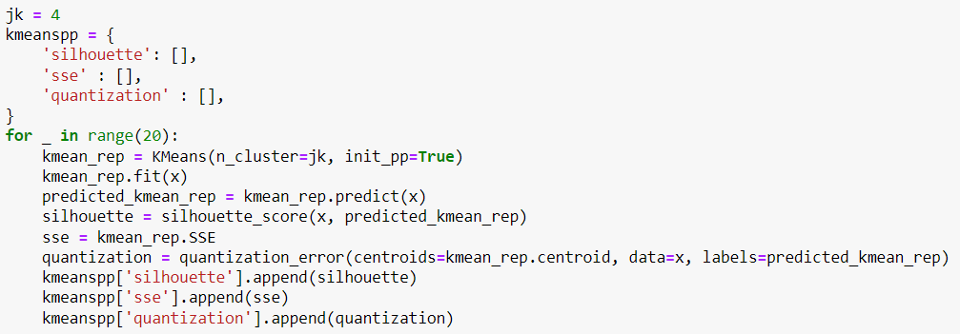

Figure 3: Clustering program code with K-Means

Clustering with PSO and K-Means
The PSO particle representation in optimizing the centroid value in the K-Means clustering algorithm influences the clustering results. Particle representation is generated in the form of numerical and integer categories according to the constraints of each parameter. PSO K-Means Clustering Hybrid Cycle :
Step 1: initialize
- Initialize PSO parameters like n, wmax, wmin, c1, and c2.
- Initialization of particles representing the centroid value of each cluster and velocity.
Step 2: update
- Update the position of each particle and calculate its fitness value using K-Means
- Update the best position for each particle.
- Update the best overall position of the particle.
Step 3: random injection
- Enters randomly generated p particles for each q iteration.
Step 4: stop condition
- If the iteration has not been completed, do step 2, and it has stopped

The PSO particle representation in optimizing the centroid value in the K-Means clustering algorithm influences the clustering results. Particle representation is generated in the form of numerical and integer categories according to the constraints of each parameter. The PSO optimization program code for the K-Means clustering algorithm is shown in Figure 4.
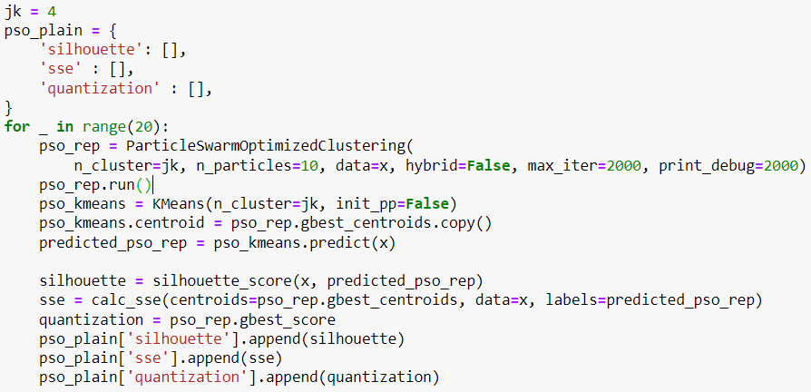

Figure 4: Clustering program code with PSO and K-Means

Clustering with Hybrid PSO and K-Means
The K-means algorithm converges faster (after evaluating fewer functions) than the PSO, but the resulting clustering is usually less accurate. The clustering process will be carried out using the PSO hybrid model in this section. Hybrid PSO is done by increasing the performance of the PSO clustering algorithm by seeding the initial swarm with the results of the K-means algorithm. This PSO hybrid algorithm first executes the K-means algorithm once. In this case, K-means clustering is terminated when (1) the maximum number of iterations is exceeded or when (2) the mean change in the centroid vector is less than 0.0001 (user-defined parameter).
The results of the K-means algorithm are then used as one of the particles, while the rest of the swarm is initialized randomly. The PSO best algorithm as presented in Figure 4 is then executed. The PSO hybrid program code is shown in Figure 5.
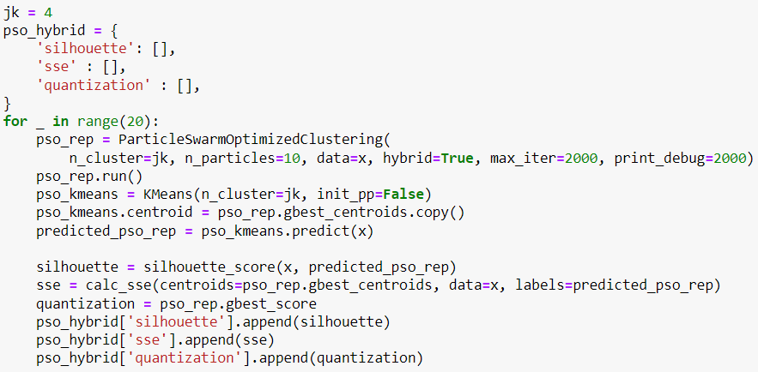

Figure 5: PSO hybrid and K-Means clustering program code

CONCLUSIONS AND RECOMMENDATIONS
The results of clustering the number of translated verses of the Qur'an produced using the K-Means, PSO, and K-Means algorithms, as well as hybrid PSO and K-Means, are shown in Figure 6.
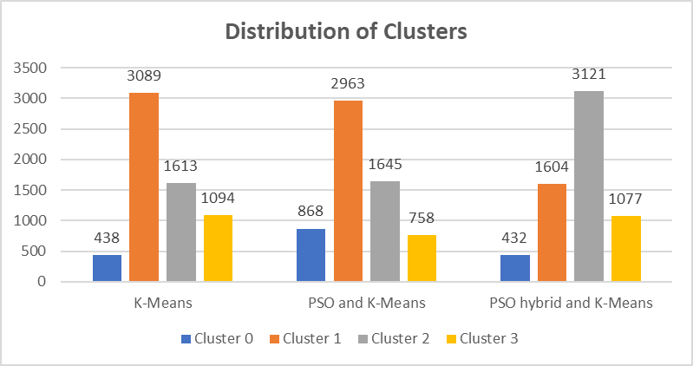

Figure 6: Distribution of data from clustering

Figure 2 shows the results of the distribution of the number of verses in each cluster generated by the three clustering models. From the three algorithms used, it can be seen that the tendency of the data generated in the K-Means algorithm and the combination of PSO and K-Means clustering has the same direction, and the use of the hybrid PSO algorithm and K-Means clustering produces a model of the amount of data that tends to be different from the K-Means algorithm and combinations of PSO and K-Means.
The clustering results will then calculate the value of the Sum of Squared Error (SSE), silhouette coefficient, and quantization score to compare the clustering effects. SSE is the sum of the squared values of the distance between the data and the cluster center. The program code to compare the results of the clustering is shown in Figure 7.

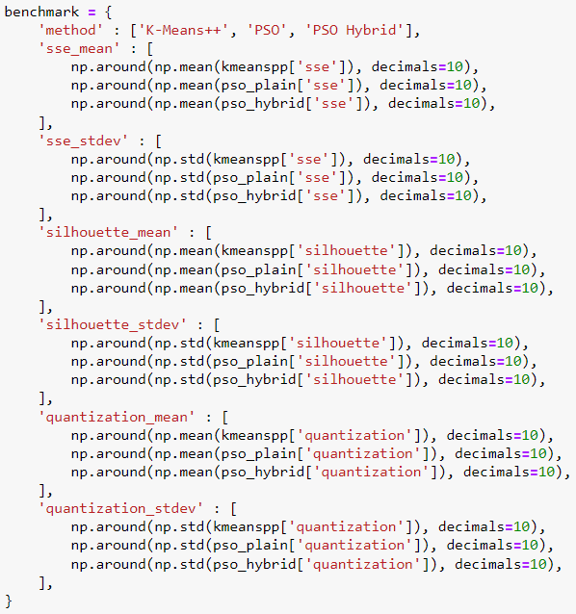

Figure 7 : Program code for comparison of results of three clustering models

The results of the program execution shown in Figure 7 are shown in Figure 8 below:
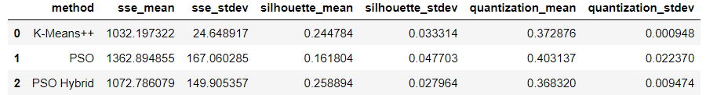

Figure 8: Comparison of results of three clustering models
Figure 8 shows that the K-Means algorithm generated the lowest SSE value, and the silhouette score and quantitative error score were generated by the PSO hybrid algorithm and K-Means clustering.

Discussion
To test the consistency of the models included in each cluster, the clustering results obtained from the three models were tested using a confusion matrix. The program code for calculating the confusion matrix is shown in Figure 9.

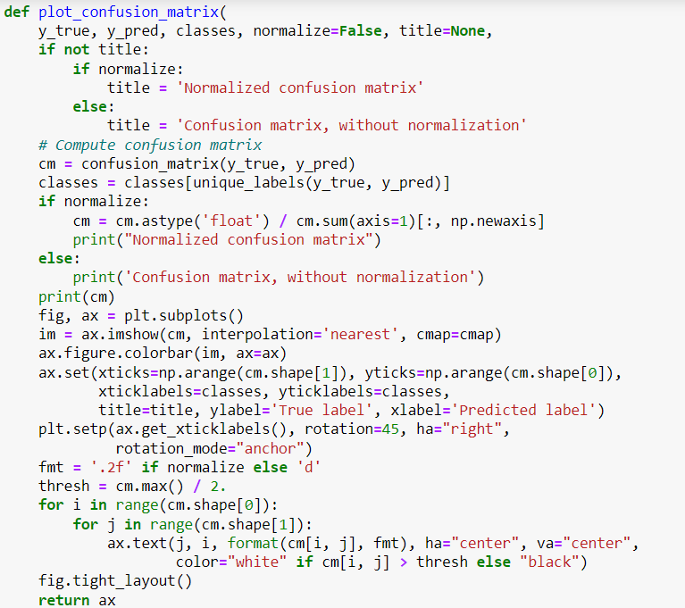

Figure 9 : Program code to calculate the confusion matrix
The execution of the confusion matrix calculation program code results in the consistency values of each cluster formed for the three models as presented in Figure 10.
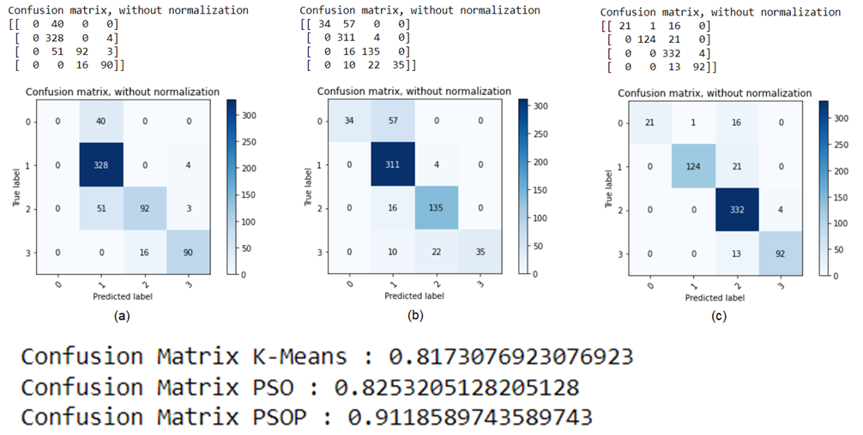

Figure 10: The results of the confusion matrix
The calculation of the confusion matrix generated in Figure 4 shows that the lowest accuracy result is produced by K-Means clustering of 0.817 (81.7%). The highest accuracy results were obtained by PSO hybrid and K-Means clustering, which was 0.911 (91.1%).
Based on the resulting confusion matrix, it can be concluded that the clustering process with K-Means clustering optimized with PSO in the Indonesian translation of the Koran gives better results when compared to the clustering process with K-means clustering without optimization.

acknowledgement (bold, 10 pt)
This research was funded by Lembaga Penelitian dan Pengabdian kepada Masyarakat (LPPM) UIN Sunan Kalijaga based on the Chancellor's Decree of UIN Sunan Kalijaga No. 127.3 of 2021 concerning Penetapan Judul dan Personalia Penelitian Terapan Kajian Strategis UIN Sunan Kalijaga Yogyakarta in 2021.

References/Bibliography
Abualigah, L. M., Khader, A. T. and Hanandeh, E. S. (2018) ‘A new feature selection method to improve the document clustering using particle swarm optimization algorithm’, Journal of Computational Science, 25(September), pp. 456–466. doi: 10.1016/j.jocs.2017.07.018.
Aggarwal, C. C. and Zhai, C. X. (2013) Mining text data, Mining Text Data. Springer US. doi: 10.1007/978-1-4614-3223-4.
Agusta, Y. (2007) ‘K-Means – Penerapan, Permasalahan dan Metode Terkait’, Jurnal Sistem dan Informatika, 3.
B. Santosa (2007) Data mining teknik pemanfaatan data untuk keperluan bisnis. Yogyakarta: Graha Ilmu.
Basari, A. S. H. et al. (2013) ‘Opinion mining of movie review using hybrid method of support vector machine and particle swarm optimization’, Procedia Engineering, 53, pp. 453–462. doi: 10.1016/j.proeng.2013.02.059.
Bisilisin, F. Y., Herdiyeni, Y. and Silalahi, B. P. (2017) ‘Optimasi K-Means Clustering Menggunakan Particle Swarm Optimization pada Sistem Identifikasi Tumbuhan Obat Berbasis Citra’, Jurnal Ilmu Komputer dan Agri-Informatika, 3(1), p. 37. doi: 10.29244/jika.3.1.37-46.
Kaur, P. (2017) ‘Outlier Detection Using Kmeans and Fuzzy Min Max Neural Network in Network Data’, Proceedings - 2016 8th International Conference on Computational Intelligence and Communication Networks, CICN 2016, pp. 693–696. doi: 10.1109/CICN.2016.142.
Khotimah, T. (2014) ‘Pengelompokan Surat Dalam Al Qur ’ an Menggunakan Algoritma K-Means’, Jurnal SIMETRIS, 5(1), pp. 83–88.
Van Der Merwe, D. W. and Engelbrecht, A. P. (2003) ‘Data clustering using particle swarm optimization’, 2003 Congress on Evolutionary Computation, CEC 2003 - Proceedings, 1, pp. 215–220. doi: 10.1109/CEC.2003.1299577.
Niu, Q. and Huang, X. (2011) ‘An improved fuzzy C-means clustering algorithm based on PSO’, Journal of Software, 6(5), pp. 873–879. doi: 10.4304/jsw.6.5.873-879.
R.Wahyudi, M. D. (2019) ‘Penerapan Algoritma Cosine Similarity pada Text Mining Terjemah Al- Qur ’ an Berdasarkan Keterkaitan Topik’, Semesta Teknika, 22(1), pp. 41–50. doi: 10.18196/st.221235.
Rustam, S., Santoso, H. A. and Supriyanto, C. (2018) ‘Optimasi K-Means Clustering Untuk Identifikasi Daerah Endemik Penyakit Menular Dengan Algoritma Particle Swarm Optimization Di Kota Semarang’, ILKOM Jurnal Ilmiah, 10(3), pp. 251–259. doi: 10.33096/ilkom.v10i3.342.251-259.
Tan, L. (2015) ‘A clustering K-means algorithm based on improved PSO algorithm’, Proceedings - 2015 5th International Conference on Communication Systems and Network Technologies, CSNT 2015, pp. 940–944. doi: 10.1109/CSNT.2015.223.
Wahono, R. S. and Suryana, N. (2013) ‘Combining particle swarm optimization based feature selection and bagging technique for software defect prediction’, International Journal of Software Engineering and its Applications, 7(5), pp. 153–166. doi: 10.14257/ijseia.2013.7.5.16.
Wahyudi, M. D. R. (2020) ‘Evaluation of TF-IDF Algorithm Weighting Scheme in The Qur ’ an Translation Clustering with K-Means Algorithm’.

