Classification of COVID-19 Cough Sounds using Mel Frequency Cepstral Coefficient (MFCC) Feature Extraction and Support Vector Machine
Muhammad Meftah Mafazy¹, Mohammad Reza Faisal², Dwi Kartini³, Fatma Indriani⁴, Triando Hamonangan Saragih⁵
^{1,2,3,4,5}Computer Science, Faculty Mathematics and Natural Science, Lambung Mangkurat, Indonesia
E-mail: meftah.mafazy@gmail.com¹, reza.faisal@ulm.ac.id², dwikartini@ulm.ac.id³, f.indriani@ulm.ac.id⁴, triando.saragih@ulm.ac.id⁵

A R T I C L E I N F O |  | ABSTRACT
History of the article:  Received January 1, 2019  Revised January 21, 2019  Accepted January 12, 2019 |  | A lot of research has been carried out to detect COVID-19, such as swabs, rapid antigens, and using x-ray images. However, this method has the disadvantage that it requires taking samples through physical contact with the patient. One way to avoid physical contact is to use audio through coughing with the aim of reducing the transmission of COVID-19. Audio feature extraction such as the Mel Frequency Cepstral Coefficient (MFCC) has often been used in audio classification research, such as the classification of musical genres and so on. This study aims to compare more or less the features of audio classification performance through coughing sounds for early detection of COVID-19 using a Support Vector Machine based on the Linear and Radial Basis Function (RBF). The dataset used is the COVID-19 Cough audio dataset, before classifying, the audio data is processed into a spectrogram and then feature extraction is carried out. Classification is divided into 2 schemes, using default parameters, then using the specified configuration parameters. From the research results, the highest AUC is 0.572266 in the linear kernel-based SVM classification. Meanwhile, when using the RBF kernel, the highest AUC is 0.560181.
Keywords:
COVID-19
Feature Extraction
Classification
Audio Cough
SVM

Correspondece:
E-mail: reza.faisal@ulm.ac.id

INTRODUCTION
Coronavirus 2019 (COVID-19) is a new disease symptom that has never been found to infect humans before. The virus that causes COVID-19 is Sars-CoV-2 (Putri, 2020). Currently, many studies have conducted COVID-19 detection, several ways to detect are swabs, rapid antigens, and using x-ray media. this collection of methods has the disadvantage of requiring physical contact sampling with the patient (Yanti, Ismida, & Sarah, 2020). Like the research conducted by (Nugroho, 2021) namely classifying x-ray images using the KNN algorithm with Haralick Features & Histogram of Oriented Gradient feature extraction, the average accuracy is above 90% with an estimated k value of 10.
One of the symptoms of COVID-19 is coughing so that through coughing sounds can be done for early detection of COVID-19. The purpose of early detection of COVID-19 is to reduce the spread and physical contact between patients and medical personnel. Classification of cough through tuberculosis screening with audio data using MFCC and ZCR feature extraction and the Logistic Regression algorithm obtained an AUC result of 0.86, then Sequential Forward Selection (SFS) feature selection was carried out to get an increase in AUC results of 0.94 (Pahar et al., 2021). Then, research conducted by (Ritwik, Kalluri, & Vijayasenan, 2021) detected COVID-19 using SVM and MFCC feature extraction, this study used the DiCOVA dataset, obtained an AUC of 0.734. In addition, there is also research conducted by (Han et al., 2021) diagnose COVID-19 through sound and other symptoms using SVM and Zero Crossing Rate feature extraction, this study uses data from the "COVID-19 Sounds App" application, after preprocessing the data, 828 audio data were obtained, then an AUC of 0.79 was obtained.
MFCC feature extraction is often used in research to detect COVID-19, such as research conducted by (Bansal, Pahwa, & Kannan, 2020) conducted cough classification as a medium for MFCC feature-based COVID-19 detection using Convolutional Neural Networks (CNN). From the results of this study, the model accuracy was 70.58%. These results are still relatively low compared to research conducted by (Södergren, Nodeh, Chhipa, Nikolaidou, & Kovács, 2021) who conducted research to detect COVID-19 through cough sound recordings using the Random Forest and Support Vector Machine (SVM) algorithms, this study used the DiCOVA dataset which amounted to 1040 data. This study uses several feature extractions, one of which is MFCC, in this study getting an AUC of 85.21% in the SVM algorithm after improvising from previous results which only reached 85.05%.
Cross-validation is a data resampling method that aims to assess the generalization ability of predictive models and prevent overfitting (Berrar, 2019). K-fold cross validation is often used in COVID-19 classification research through cough audio as done by (Tena, Clarià, & Solsona, 2022) classifying COVID-19 through sound detection using SVM and 10-fold cross validation obtained an AUC of 89.49%.
Support Vector Machine or SVM is quite popular for classification tasks in COVID-19 symptom detection (Chowdhury, Kabir, Rahman, & Islam, 2022). The advantage of SVM is that not all training data will be considered relevant in each training iteration. These contributing data are called support vectors so the method is called Support Vector Machine. The concept of classification with SVM can simply be explained as an attempt to find the hyperplane with the best performance to separate two classes of data in the input space (Prasetyo, 2012). In research conducted by (Danika, Raharjo, & Hidayat, 2022) detecting guitar sounds using RBF-based SVM from the classification obtained an accuracy of 95%.
From the explanation above, researchers will conduct research, namely comparing SVM performance when using MFCC feature extraction with SVM performance when using MFCC feature extraction on cough audio classification for early detection of COVID-19. Researchers will use the COVID-19 Cough Dataset with 1284 instances for healthy and 642 instances for COVID-19. The prediction model that will be used is the Support Vector Machine (SVM) based on the Linear and Radial Basis Function (RBF) kernel.

RESEARCH METHODS
There are research methods that will be carried out to ensure the smooth running of the research in line with the objectives, as well as to determine the SVM kernel that has the best performance in cough classification for COVID-19 detection. The flow of research methods can be seen in Figure 1.
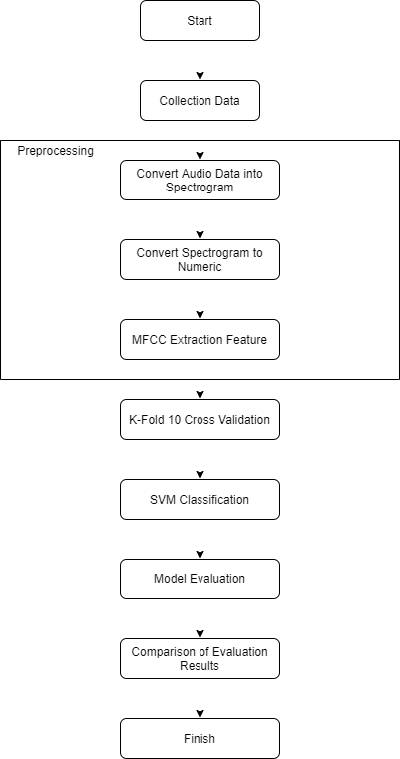
Figure 1. Research Flow
- Data Collection
Data collection was carried out from the Kaggle site under the name COVID-19 Cough with a total dataset of 1926 audio data labeled Healthy and COVID-19 with a ratio of 1284:642 data. Examples of sound wave graphs labeled Healthy and COVID-19 can be seen in Figure 2 and Figure 3.
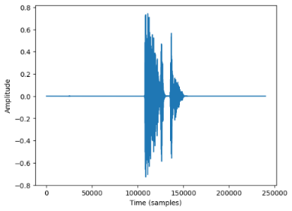  Figure 2. Cough audio labeled Healthy | 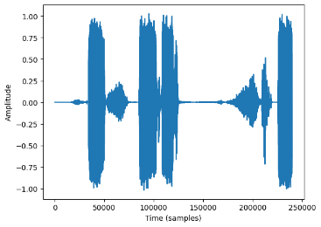  Figure 3. Audio cough labeled COVID-19

The list of initial labeled datasets can be seen in Table 1.
Table 1. Initial dataset
No | filename | label
1 | 00039425-7f3a-42aa-ac13-834aaa2b6b92.wav | healthy
2 | 0009eb28-d8be-4dc1-92bb-907e53bc5c7a.wav | healthy
…. | …. | ….
1925 | ff8363d2-016d-4738-9499-4c62480886fb.wav | COVID-19
1926 | ffe0658f-bade-4654-ad79-40a468aabb03.wav | COVID-19

- Data Preprocessing
Preprocessing is a process that makes it easier to produce values from feature extraction (Solehudin, 2018). The part that the author does is converting raw audio data into 2-dimensional data, namely spectrograms, then MFCC feature extraction using the librosa library in the python programming language (McFee et al., 2023). The following are the stages of preprocessing audio data :
- Audio Data Conversion
Preprocessing that will be done in this research is to convert audio data into visual data in the form of a spectrogram, a spectrogram is a visual representation of the frequency spectrum of an audio signal. Spectrograms in the form of images show which axis represents time and the other axis represents frequency, and the color at each point represents amplitude (Zeng, Mao, Peng, & Yi, 2019). The data that has been converted into a spectrogram can be seen in Figure 4.
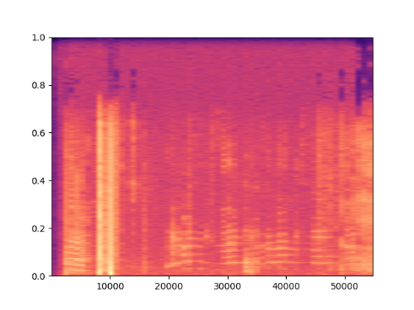
Figure 4. Spectrogram
After preprocessing into a spectrogram, feature extraction is carried out which later spectrogram data will become numerical data. For the initial features extracted, there are 8 features such as File Name, Chroma Short Time Fourier Transform, Root Mean Square Error, Spectral Centroid, Spectral Bandwidth, Spectral Rolloff, Zero Crossing Rate, and Mel Frequency Cepstral Coefficient.
No | Filename | chroma_stft | rmse | spectral_centroid | … | label
1 | 00039425-7f3a-42aa-ac13-834aaa2b6b92.wav | 0,131107 | 0,018705 | 622,641 | … | healthy
2 | 0009eb28-d8be-4dc1-92bb-907e53bc5c7a.wav | 0,396538 | 0,096149 | 1881,525 | … | healthy
…. | … | … | … | … | … | …
1925 | ff8363d2-016d-4738-9499-4c62480886fb.wav | 0,567204 | 0,030467 | 2250,516 | … | COVID-19
1926 | ffe0658f-bade-4654-ad79-40a468aabb03.wav | 0,571835 | 0,153279 | 2543,526 | … | COVID-19

- Mel Frequency Cepstral Coefficient (MFCC) Feature Extraction
MFCC is a feature extraction that transforms the linear cosine of the short-time logarithmic power spectrum of a speech signal on a non-linear Mel frequency scale. (Solehudin, 2018). In the dataset obtained, the MFCC feature extraction will be carried out as many as 10 coefficients. The total number of features used in the dataset when combined with the initial 8 features amounts to 18 features. Meanwhile, examples of MFCC coefficients that successfully extracted features can be seen in Table 2.
Table 2. MFCC Feature Extraction 10 Coefficients
No | mfcc1 | mfcc2 | mfcc3 | mfcc4 | … | mfcc10
1 | -5.431 | 23.290.40 | -57.572 | 9.078.011 | … | -4.068.914.413
2 | -2.788 | 1.022.039 | -26.285 | 15.891.88 | … | -3.383.172.035
…. | … | … | … | … | … | …
1925 | -4.835.52 | 23.290.409 | 3.146.038 | 12.320.159 | … | 29.576.611.518.859
1926 | -26.747.9 | 23.290.409 | -50.933.16 | 32.873.756 | … | -36.501.495.838

- 10 K-Fold Cross Validation
Cross-validation itself is usually defined as a statistical method used to evaluate the performance of algorithms that have been made. Where the data is separated into 2 types, namely training data and testing data (Primartha, 2018). This stage divides the training data and test data using K-Fold Cross Validation with a value of k = 10. The data will be divided into 10 subsets that have the same number of classes.
- Support Vector Machine (SVM) Classification
SVM itself is divided into several kernels, such as Radial Basis Function (RBF) kernel and linear kernel. RBF is a kernel concept that aims to classify data that cannot be linearly separated. Meanwhile, the linear kernel is a popular SVM kernel. Linear functions are often used to measure the similarity or dot product between two input vectors. Linear kernels can also ensure global optimization for regression or classification problems in small and large data sets and adopt predictive binary classification, i.e. the assignment of class labels to unlabeled data (Naicker, Adeliyi, & Wing, 2020). In this study, we will use RBF kernel parameters as well as linear kernel, C value, and gamma. The RBF kernel-based SVM equation is defined in equation 1 (Pambudi, 2022), while the linear kernel-based SVM is defined in equation 2 below (Huang, Zhu, Wang, & Fang, 2021).
$$K\left(x_{i},x_{j}\right)=exp⁡(-\frac{{||x_{i}-x_{j}||}^{2}}{{2σ}^{2}})$$ | (1)

$$K\left(x_{i},x_{j}\right)=\left(x_{i}.x_{j}\right)$$ | (2)
Meanwhile, the gamma value can be defined in equation 3 and equation 4.
$$gamma=\frac{1}{(2*variance)})$$ | (3)
$$variance=\left(\frac{1}{N}\right)*\sum{{(x_{i}-μ)}^{2}}$$ | (4)

The classification flow consists of 2 flows, namely SVM classification with default parameter initialization, and SVM classification with the specified parameter configuration defined in Table 4 and Table 5.
Table 3. SVM Default Parameter Values
Parameters | Description | Values
Kernel | Transforms the original feature space into an infinite feature space. | RBF & Linear
C | Controlling between margin and misclassification in SVM models. | 1
Gamma | Control how much influence each center point has on the mapping. | 0,062

Table 4. SVM Manual Configuration Parameter Values
Parameters | Description | Values
Kernel | Transforms the original feature space into an infinite feature space. | RBF & Linear
C | Controlling between margin and misclassification in SVM models. | 0,1 - 1
Gamma | Control how much influence each center point has on the mapping. | 0.062

- Evaluation
After obtaining the classification results, further evaluation is carried out on the performance of each feature coefficient and feature combination so that 4 models are tested. For performance evaluation using Area Under Curve (AUC).

RESULTS AND DISCUSSION
Before performing classification, data collection and data preprocessing are carried out. The dataset used in this research is the COVID-19 Cough dataset. The initial dataset contains 1926 cough audio files that have different durations. This dataset has two classes consisting of 1284 healthy classes and 642 COVID-19 classes with a comparison of the percentage of healthy patient classes by 67% and the percentage of COVID-19 patient classes by 33% which is represented in the diagram in Figure 5.
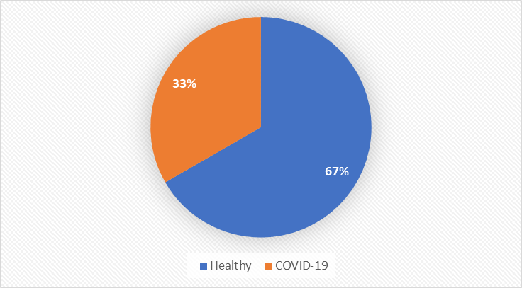
Figure 5. Comparison of Percentage of Healthy and COVID-19 Patients
After data collection, data preprocessing is carried out by converting audio into a visual representation in the form of a spectrogram, from the spectrogram, MFCC feature extraction is carried out as many as 10 coefficients. After preprocessing the data, classification is carried out with 2 schemes, classification using RBF kernel-based SVM and Linear kernel-based SVM classification with gamma and C parameters that have been determined in table 3 and table 4 based on research (Chowdhury et al., 2022).
The first RBF kernel-based SVM classification study was conducted with the help of the SVC library in the python programming language as well as the gamma parameters and C values that have been set according to Table 3 and Table 4. From the classification experiment, the highest AUC was obtained of 0.560181 in the default parameter and parameter configuration with a value of C = 1. While the low AUC value was obtained of 0.551147 in the parameter configuration with a value of C = 0.2. The overall AUC performance in the RBF kernel-based SVM classification experiment is summarized in a graph that can be seen in Figure 6 below.
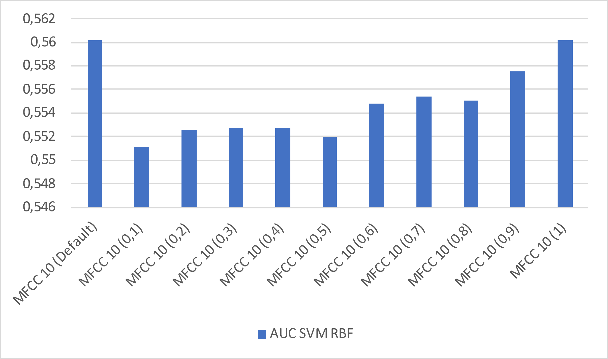
Figure 6. Comparison of AUC Graphs on RBF kernel-based SVM Classification
The second study of linear kernel-based SVM classification was conducted with the help of the SVC library in the python programming language as well as the gamma parameters and C values that have been set according to Table 3 and Table 4. From the classification experiment, the highest AUC was obtained as 0.572266 in the parameter configuration with a value of C = 0.5. Meanwhile, the lowest AUC value was obtained at 0.462402 in the parameter configuration with a value of C = 0.8. The overall AUC performance in the linear kernel-based SVM classification experiment is summarized in the graph that can be seen in Figure 7 below.
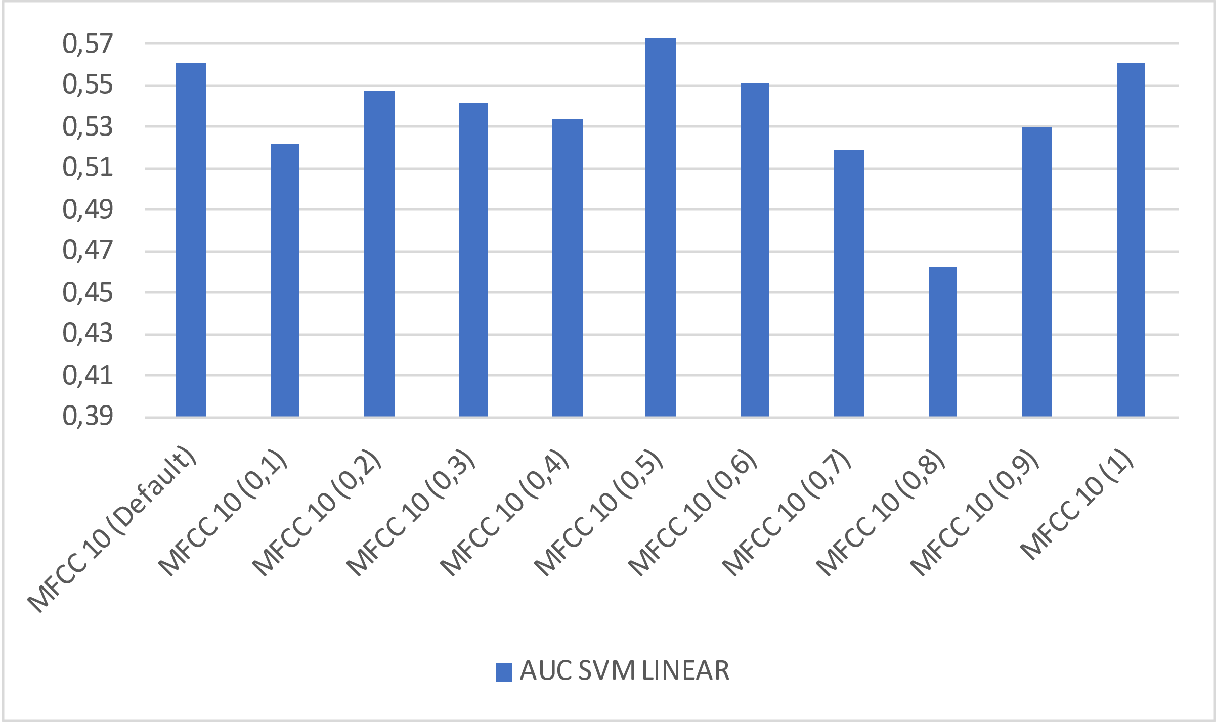
Figure 7. Comparison of AUC Graphs on Linear kernel-based SVM Classification
From the 2 classification experiments above using SVM based on RBF and Linear kernels, the best AUC is summarized which can be seen in Figure 8.
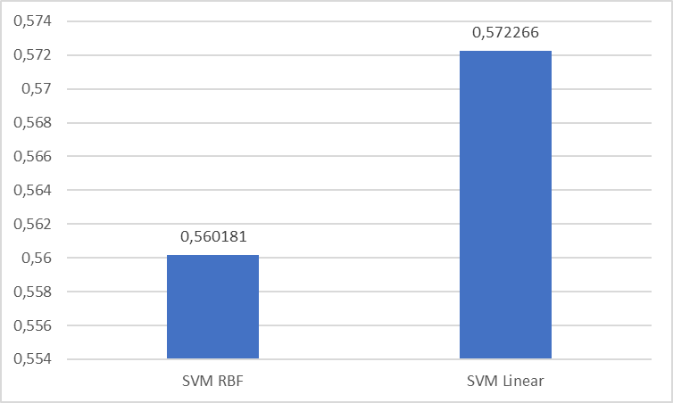
Figure 8. Comparison of AUC Graphs on SVM RBF and Linear classification
The graph above shows that the highest AUC in SVM classification is by using a linear kernel which is 0.572266. Meanwhile, when using the RBF kernel, SVM classification only gets an AUC performance of 0.560181.

CONCLUSIONS AND RECOMMENDATIONS
Early detection of COVID-19 through cough audio is carried out using the COVID-19 Cough dataset based on research conducted. This dataset has 1926 instances with 2 classes consisting of 1284 healthy and 642 COVID-19. The class percentage comparison on the dataset is around 67% healthy and 33% positive for COVID-19. From the percentage of data, it can be concluded that the COVID-19 Cough dataset includes imbalanced data or unbalanced data. The data will be preprocessed first, such as converting audio data into visual data in the form of spectrograms, then feature extraction is carried out so that it becomes numerical data in the form of MFCC feature extraction. After preprocessing, the dataset will be stratified using Stratidied K-Fold 10 Cross Validation so that the proportion of class comparison in training data and testing data is the same. Classification in this study uses 2 SVM kernels, namely RBF kernel-based SVM and linear-based SVM. This research was conducted with the help of using the SVC library in the python programming language. From the research results, the highest AUC of 0.572266 was obtained in the linear kernel-based SVM classification. Meanwhile, when using the RBF kernel, the highest AUC is 0.560181. Suggestions given based on this research are to perform other audio extractions such as spectral flux, spectral entropy and use feature selection algorithms such as genetic algorithms.

ACKNOWLEDGEment
We would like to thank LPPM Lambung Mangkurat University and the Data Science Laboratory, Department of Computer Science, Faculty of Mathematics and Natural Sciences, Lambung Mangkurat University for supporting the Program Dosen Wajib Meneliti (PDWM).

References
Bansal, V., Pahwa, G., & Kannan, N. (2020). Cough classification for COVID-19 based on audio mfcc features using convolutional neural networks. 2020 IEEE International Conference on Computing, Power and Communication Technologies, GUCON 2020 (pp. 604–608). Institute of Electrical and Electronics Engineers Inc.
Berrar, D. (2019). Cross-Validation.
Chowdhury, N. K., Kabir, M. A., Rahman, M. M., & Islam, S. M. S. (2022). Machine learning for detecting COVID-19 from cough sounds: An ensemble-based MCDM method. Computers in Biology and Medicine, 145. Elsevier Ltd.
Danika, A., Raharjo, J., & Hidayat, B. (2022). Deteksi Suara Gitar Dengan Bahan Jenis Senar Berbeda Melalui Ciri Akustik Dengan Mel-Frequency Cepstral Coefficients (MFCC) Dan Support Vector Machine (SVM) Guitar String Detection Through Acoustic Characteristics Using Mel-Frequency Cepstral Coefficients. e-Proceeding of Engineering, 8, 2936–2942.
Han, J., Brown, C., Chauhan, J., Grammenos, A., Hasthanasombat, A., Spathis, D., Xia, T., et al. (2021). Exploring Automatic COVID-19 Diagnosis via Voice and Symptoms from Crowdsourced Data. ICASSP 2021 - 2021 IEEE International Conference on Acoustics, Speech and Signal Processing (ICASSP) (pp. 8328–8332).
Huang, B., Zhu, Y., Wang, Z., & Fang, Z. (2021). Imbalanced data classification algorithm based on clustering and SVM. Journal of Circuits, Systems and Computers, 30(02), 2150036. World Scientific.
McFee, B., McVicar, M., Faronbi, D., Roman, I., Gover, M., Balke, S., Seyfarth, S., et al. (2023, March). librosa/librosa: 0.10.0.post2. Zenodo.
Naicker, N., Adeliyi, T., & Wing, J. (2020). Linear support vector machines for prediction of student performance in school-based education. Mathematical Problems in Engineering, 2020, 1–7. Hindawi Limited.
Nugroho, C. A. (2021). Klasifikasi k-nearest neighbor chest X-ray pasien Covid-19 dengan haralick features dan histogram of oriented gradient. MATHunesa: Jurnal Ilmiah Matematika, 9(1), 188–195.
Pahar, M., Klopper, M., Reeve, B., Warren, R., Theron, G., & Niesler, T. (2021). Automatic cough classification for tuberculosis screening in a real-world environment. Physiological Measurement, 42(10), 105014. IOP Publishing.
Pambudi, R. (2022). Deteksi Penggunaan Masker dengan Algoritma RBF Support Vector Machine. The Journal on Machine Learning and Computational Intelligence (JMLCI), 1(2).
Prasetyo, E. (2012). Data mining konsep dan aplikasi menggunakan matlab. Yogyakarta: Andi, 1.
Primartha, R. (2018). Belajar Machine Learning Teori dan Praktik. Bandung: Informatika Bandung, 10, 20–30.
Putri, R. N. (2020). Indonesia dalam Menghadapi Pandemi Covid-19. Jurnal Ilmiah Universitas Batanghari Jambi, 20(2), 705. Universitas Batanghari Jambi.
Ritwik, K. V. S., Kalluri, S. B., & Vijayasenan, D. (2021). COVID-19 Detection from Spectral Features on the DiCOVA Dataset. Interspeech (pp. 936–940).
Södergren, I., Nodeh, M. P., Chhipa, P. C., Nikolaidou, K., & Kovács, G. (2021). Detecting COVID-19 from audio recording of coughs using Random Forests and Support Vector Machines. Proceedings of the Annual Conference of the International Speech Communication Association, INTERSPEECH (Vol. 6, pp. 4256–4260). International Speech Communication Association.
Solehudin, R. (2018). Implementasi Metode MFCC (Mel Frequency Cepstral Coefficient) Dan Naive Bayesian Untuk Klasifikasi Nada Dasar Gitar. Universitas Komputer Indonesia.
Tena, A., Clarià, F., & Solsona, F. (2022). Automated detection of COVID-19 cough. Biomedical Signal Processing and Control, 71, 103175.
Yanti, B., Ismida, F. D., & Sarah, K. E. S. (2020). Perbedaan uji diagnostik antigen, antibodi, RT-PCR dan tes cepat molekuler pada Coronavirus Disease 2019. Jurnal Kedokteran Syiah Kuala, 20(3).
Zeng, Y., Mao, H., Peng, D., & Yi, Z. (2019). Spectrogram based multi-task audio classification. Multimedia Tools and Applications, 78, 3705–3722. Springer.

