Convolutional Neural Networks for Classification of Lung Cancer Based on Histopathological Images

Sarifah Agustiani ¹, Denny Pribadi ², Agus Junaidi ³, Siti Khotimatul Wildah ⁴, Ali Mustopa ⁵, Yoseph Tajul Arifin ⁶
^{1, 4} Computer Technology, Faculty of Engineering and Informatics
² Computer Science, Faculty of Engineering and Informatics
³ Information Technology, Faculty of Engineering and Informatics
⁵ Technical Information of Campus Pontianak City, Faculty of Engineering and Informatics
⁶ Electrical Engineering, Faculty of Engineering and Informatics
^{1, 2, 3, 4, 5, 6} Universitas Bina Sarana Informatika

E-mail: sarifah.sgu@bsi.ac.id ¹, denny.dpi@bsi.ac.id ², agus.asj@bsi.ac.id ³ , siti.ska@bsi.ac.id ⁴, alimustopa.aop@bsi.ac.id ⁵, yoseph.ypa@bsi.ac.id ⁶

A R T I C L E I N F O |  | ABSTRACT
History of the article:  Received January 1, 2019  Revised January 21, 2019  Accepted January 12, 2019 |  | Lung cancer is one of the deadliest types of cancer characterized by the uncontrolled growth of cancer cells in the lung tissue due to the accumulation of carcinogens. Lung cancer ranks second in the most cases with 2.206 million new cases and ranks first in deaths. This lung cancer often does not cause symptoms in the early stages, because it only appears after the tumor is large enough or the cancer has spread to surrounding tissues or organs, so it is necessary to have early detests to prevent severity and determine follow-up treatment. This study aims to classify lung cancers using digital pathology images with data of 15000 images obtained from the LC25000 dataset containing 5,000 images for each class. The method used in this classification process uses convolutional neural networks (CNN) which is one of the implementations of Deep Learning used for digital image processing. Using this method, the doctor can diagnose and find out the type of lung cancer quickly without spending much time. Thus, the faster the prediction results received by the doctor / health expert, the faster the next action or handler will be, this study produces a fairly accurate accuracy value even though it uses a shallow CNN architecture because it only consists of 5 layers with 3 convolution layers and 2 fully connected layers, with the resulting accuracy value of 98.53%.
Keywords:
CNN,
Lung Cancer,
Histopathology

Correspondece:
Telepon: +62 89646363255
E-mail: sarifah.sgu@bsi.ac.id

INTRODUCTION
Cancer is a disease characterized by changes in normal cells in the body that cause uncontrolled and abnormal cell division, both in the tissues closest to and farthest from the cancer cells. In 2018, WHO revealed that an estimated 9.6 million people worldwide died of cancer. In the same year, the International Agency for Research on Cancer (IARC) announced that there were 18.1 million new cancer cases and 9.6 million cancer deaths worldwide (Abdulah, 2022). In 2020 it accounted for nearly 10 million deaths, of which one in six deaths was caused by cancer and one of them was lung cancer (Buana & Harahap, 2022).
Lung cancer is one of the deadliest types of cancer characterized by uncontrolled growth of cancer cells in the lung tissue due to the accumulation of carcinogens (Septiani et al., 2022). Based on data from Global Burden of Cancer (GLOBOCAN) released by the World Health Organization (WHO) noted that in 2020 lung cancer ranked second in the most cases with the number of new cases as many as 2,206,771 case and the death rate ranks first with 1,796,144 cases (Ferlay J, Ervik M, Lam F, Colombet M, Mery L, Piñeros M, Znaor A, Soerjomataram I, 2020).
Cancer mortality depends on the prognosis of the type of cancer the patient has. The quality of medical services provided during treatment also affects the patient's prognosis (Pangribowo, 2019). The poor prognosis of the disease is closely related to the rarity of patients who come to the doctor when the disease is still in its early stages. As with most other types of cancer, the exact cause of this lung cancer is not yet known, and most lung cancers have no symptoms. So that sufferers can live for years without knowing that they have lung cancer. Because lung cancer is only detected when a CT scan or chest X-ray is done (Amalita & Dewi, 2021). Which of the results of this CT scan or X-ray doctors or medical personnel can determine the type of cancer and its severity, this will certainly affect the follow-up that will be carried out in the treatment of cancer.
Deep Learning, a branch of science that is based on machine learning and artificial neural networks (Ann), or what can be called the development of Ann, is one technique that can be employed in the categorization process. A computer can learn to identify straight from images or audio using deep learning. Deep Learning good command in English both oral and written Computer Vision, namely Image Classification or classification of objects in the image in the form of two dimensions such as images and sound (Pratiwi et al., 2021). Deep Learning useful to solve problems and make things easier, with Deep Learning, doctors can diagnose and determine the type of disease quickly without spending a lot of time and can provide results in the form of a more optimal picture (Telaumbanua et al., 2019). Thus, the faster the results of predictions received by doctors/health experts, the faster the action or handling of the disease (Sugara & Subekti, 2019).
Research conducted by (Hatuwal & Thapa, 2020), This study suggests using histopathology scans to identify lung cancer. Images from three distinct categories—benign, adenocarcinoma, and squamous cell carcinoma—were classified using an artificial neural network convolution (CNN). The accuracy of the 5-layer CNN approach utilized in this study, which has three hidden layers, one input layer, and one fully linked layer, was 96.11%.
The same study was also conducted by (Mangal et al., 2020), However, using histopathological images, two classification processes were used in this study to identify colon and lung cancer. With an accuracy rating of 97% for lung cancer and 96% for colon cancer, this study suggests using the CNN approach.
Another study (Sannasi Chakravarthy & Rajaguru, 2019), applying PNN to the classification process and GLCM and CCSA for feature selection on CT. According to the study's findings, the PNN model created with the CCSA feature performed better, with an accuracy value of 90%.
Research conducted (Sasikala et al., 2018), This study used CT scan pictures to identify and categorize lung cancer using the CNN approach. This work uses MATLAB for the second stage of classification and two stages of training to extract the volumetric feature values from the first stage. Their suggested technique has a 96% accuracy rate for classifying cancerous and non-cancerous cells.
Research (da Nóbrega et al., 2020), This study investigates how well deep transfer learning from non-medical images performs in classifying lung cancer malignancies using a variety of transfer learning techniques, such as (VGG16, VGG19, Mobile Net, Exception, InceptionV3, ResNet50, InceptionResNetV2, DenseNet169, DenseNet201, NAS Net Mobile and NAS Net Large), which are trained using the ImageNet dataset and then applied to LIDC/IDRI nodule images as feature extraction. The ResNet50 feature extraction and RBF classification using SVM, which attained an AUC metric of 93.1%, produced the highest yield.
Research (Saric et al., 2019) proposed a method for the detection of lung cancer on the entire slide of lung tissue sample images by coloring the image with hematoxylin & eosin (H&E), then scanned with an automatic microscope with a magnification of 20x. The area of cancer on the slide is described by the pathologist. Then extraction is performed on the desired region with (ROI) to ease the computational load. As for the classification, it is carried out at the image patch level using the CNN architecture, namely VGG16 and ResNet50. The results obtained showed an accuracy value of 75.41% for VGG16 and 72.05% for Resnet50.
This research uses Convolutional Neural Network (CNN) method which is one implementation of Deep Learning for digital image processing. CNN became a popular method because it managed to rank first from 2012 to 2015 in the category of Image Classification (Felix et al., 2020). The study was conducted using a dataset from the Kaggle Repository with a total of 15.000 images for the lung cancer category.

RESEARCH METHODS
In this research method, the dataset classification process is carried out using CNN by following layers and parameters ranging from input layers, convolutional layers, pooling layers, flatten layers, fully connected layers or dense layers and dropout layers. This step can be seen in the following figure:
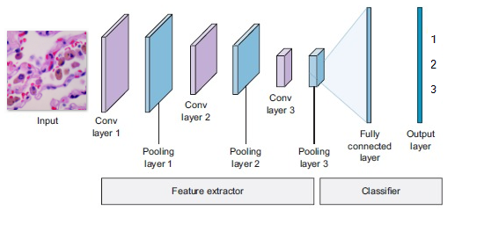
Figure 1. CNN Architecture

- Convolutional Neural Netwrok (CNN)
CNN is a Deep Learning method. CNN is a convolutional operation that integrates many processing layers, uses multiple components that operate in parallel, and is motivated by the biological nervous system. CNN displays each neuron in a two-dimensional format, so this approach is appropriate for processing input that takes the shape of a picture. (Maggiori, E., Tarabalka, Y., Charpiat, G. & Alliez, 2016). The input layer, convolution layer, pooling layer, fully-connected layer, and output layer are the five basic components of the CNN architecture. (Felix et al., 2020)
- Input Layer
Input layer is an input data image data is converted into a matrix with 3 dimensions with the value of each dimension that is red, blue and Green (Felix et al., 2020)
- Convolution Layer
It is a major part of CNN, as most of the computations on CNN are done in this layer. The operations performed are the same as convolution operations commonly performed in image processing, where there are kernels and sub images. The kernels used on CNN are generally 3x3 in size. Then for each sub image that is the same size as the kernel a convolution operation is performed (Alamsyah & Pratama, 2020).
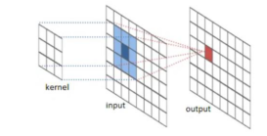
Figure 2. Convolutional Layer
- Pooling Layer
The stage after Convolutional Layer is Pooling Layer. A specific size and stride of filter makes up the pooling layer. The number of steps in the overall feature map or activation map that will be shifted determines how many steps will be shifted in each shift. Max Pooling and Average Pooling are the two pooling layer types that are frequently applied. When using Max Pooling 2x2 with Stride 2, for instance, the value taken at each filter shift is the largest value in the 2x2 area, as opposed to Average Pooling, which will take the average value (Santoso & Ariyanto, 2018).
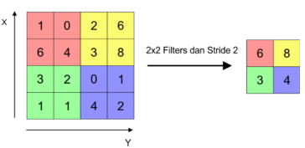
Figure 3. Pooling Layers

- Flatten Layer
Flatten layer is a layer that aims to convert two-dimensional data into one dimension. In this process, each row in the feature map will be arranged vertically (Candra & Prapanca, 2020).
- Fully Connected Layer
It is a multilayer perceptron (MLP) classification stage process or also known as neural networks. In the fully connected layer, each neuron has a full connection to all activations in the previous layer. This is exactly the same as the one in MLP. The activation model is also exactly the same as MLP, which is that computation uses a matrix multiplication followed by an offset bias (Putra & Bunyamin, 2020).
- Dropout Layer.
One strategy to avoid overfitting and hasten the learning process is to drop out. In overfitting, there is a discrepancy in the prediction process even though nearly all of the data that has undergone the training process has reached a high percentage. Dropout in its functioning system destroys a neuron in the network's Hidden Layer or Visible Layer for a brief period of time (Nugroho et al., 2020)
.

RESULTS AND DISCUSSION

This lung cancer diagnosis uses 15,000 images obtained from the kaggle repository with a total of 3 classes. Each class consists of 5,000 images that are 768 x 768 pixels in size and in jpeg file format generated from the original sample from the appropriate source and HIPAA validated. The classes in this dataset are:

1. Adenocarcinoma of the lung (Lung Aca)

2. Benign lung tissue (Lung N)

3. Squamous cell carcinoma of the lung (Lung SCC)

The following is an example of an image from the dataset used in this study:
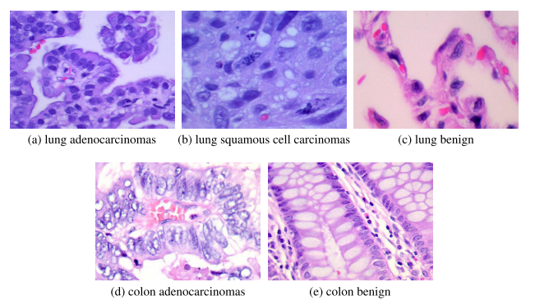
Figure 4. Dataset (Borkowski et al., 2019)
This research for the diagnosis of lung cancer uses Convolutional Neural Networks (CNN) with a layer consisting of 3 convolution layers and 2 fully connected layers. To ensure that the classification is well generalized, the data is divided into three categories, namely training data, test data, and validation data, each of which consists of 13,450 training data samples, 1,500 test data samples, and 50 validation data samples. While the epoch used is as many as 100 epochs with a batch size of 50. The following is a summary of the CNN model used in this study:

Table 1. CNN Model Summary
Layer |  | Size and Filters | Kernel Size | Activation | Pooling size
1 | Image | 64 x 64 x 3 | - | - | -
 | Convolution | 16x16 | 3x3 | relu | -
 | Max pooling | - | - | - | 2x2
2 | Convolution | 32x32 | 3x3 | relu | -
 | Max pooling | - | - | - | 2x2
3 | Convolution | 64x64 | 3x3 | relu | -
 | Max pooling | - | - | - | 2x2
Flatten |  | - | - | - | -
Dropout |  | 0,3
Dense |  | 500 |  | relu
Dropout |  | 0,4
Dense |  | 3 |  | softmax

Input Layer

In this study, the input used was 64x64 pixels with a color channel of 3 for RGB, and this layer is used to load data and enter it into the first convolution layer.

Convolution Layer
With filters that can be trained to learn the geographic and spatial structure of the image, this layer transforms input images. The model consists of three convolution layers, each with a filter size of 3x3, a kernel size of 3, a constant amount of padding, and relu activation. There are 16 filters in the first layer, 32 in the second, and 64 in the third.

Pooling Layer
The received output picture from the convolution layer is down sampled using the pooling process. Each convolution layer in this study contained one pooling layer. In this instance, Max Pooling with a pooling size of 2 is the pooling layer in use.

Fully Connected Layer or Dense Layer
This layer generates vector output by treating the input as a straightforward vector. Two dense layers were used in this investigation, the first with 512 neurons and the second with 3 neurons, depending on the number of classes. Using softmax activation, the output of this final fully connected layer is turned on.
The results of this experiment produced several values such as accuracy, loss, and prediction values in the classification of lung cancer which can be seen in the following figure:
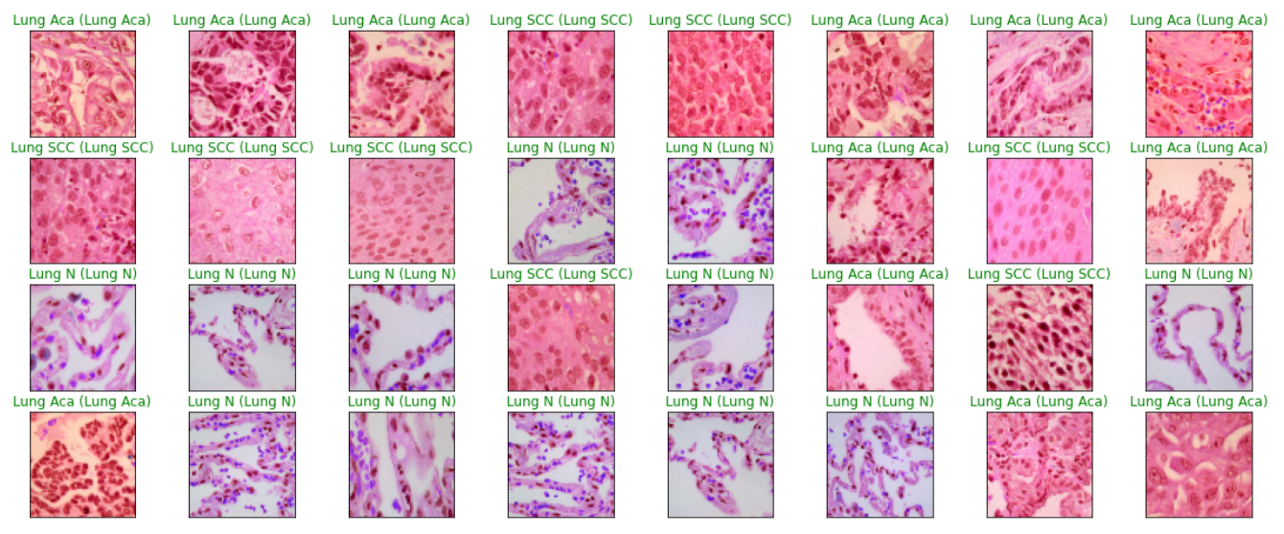
Figure 5. Sample Image Prediction
Figure 5 shows some of the predictions produced by the model proposed in this study. Based on the image, it can be explained that the image with green writing shows the prediction in accordance with the actual value, for example in the first image it is predicted lung aca and the result shows that the image is correct lung Aca. Based on the results of these predictions, it can be seen that almost all images are predicted correctly. Besides being able to be seen from the prediction results, the test results can also be seen from the accuracy value and loss value produced.
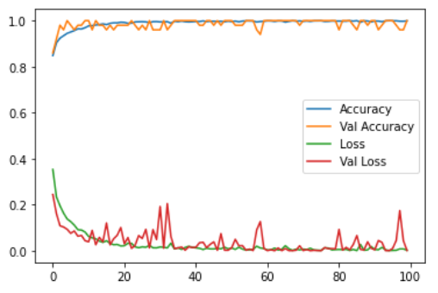
Figure 6. Plot of Model Loss and Accuracy
A graph of the obtained accuracy for each epoch is displayed in Figure 6. Based on the graph, it can be deduced that the accuracy value of each epoch increased fairly steadily from the first epoch, which had an accuracy value of 0.8485, to The Last Epoch, or the 100th epoch, which had a value of 0.9990. This indicates that the proposed model is more accurate the higher the accuracy value produced. This test not only yields an accuracy number but also a loss value, which is a measurement of an error produced by the network in an effort to reduce it. The loss value can be seen on the line in green. Based on the graph, it can be concluded that the loss of each epoch on average has decreased starting from the first epoch with a value of 0.3531 to The Last epoch, namely the 100th epoch with a value 0.0028, this means that the smaller the loss value, the smaller the error rate experienced. Meskipun in testing this model there are some significant increases in some epoch on validation loss.
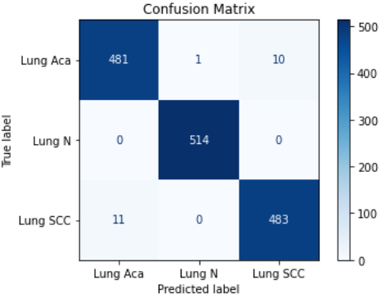
Figure 7. Confusion Matrix

The confusion matrix shown in Figure 7 illustrates the actual label with the predicted label, from the figure it can be concluded that out of 1,500 test images used there are 481 correctly predicted images as Lung Aca class, and 514 images as Lung n class and 483 images as Lung SCC Class. While 11 images were predicted as Lung Aca but the actual label turned out to be Lung SCC, and 1 image predicted as Lung N label actually turned out to be Lung Aca, and 10 images predicted Lung SCC but the actual label was Lung Aca. Overall this model is quite accurate because the prediction error rate is not more than 2%. In addition to the proposed method, this research also conducted several tests using several transfer learning models including VGG16, DensNet, Eception, MobileNet, and ResNet50. Details of the accuracy results produced by these models are shown in Table 2.
Table 2. Comparison Of Transfer Learning Methods
Method | Accurasy
VGG16 | 0,980000019
DensNet | 0,958666682
Exception | 0,915333331
MobileNet | 0,515999973
ResNet50 | 0,515999973

CONCLUSIONS
Based on experiments that have been carried out on the LC25000 dataset as an image used to train and validate the proposed model using deep learning approach, shows that this study produces a fairly high accuracy value despite using a shallow CNN architecture because it only consists of 5 layers with 3 convolution layers and 2 fully connected layers. This Model is designed to classify lung cancer using histopathological images. This study also proposed a training and evaluation strategy to train CNN architecture with an accuracy value of 98.53%.
It should be noted that this study is not intended to replace, but only complement the lung cancer diagnoses made by the experts themselves. The existence of machine learning techniques can only be predicted with the accuracy achieved, however examination by an expert is the most reliable way to diagnose this cancer. Meanwhile, this model can be used to help experts get an initial picture.

acknowledgement
The authors would like to thank all those who have supported the completion of this research process, and who have contributed both times and thought. The author would also like to thank Mr. Andrew A. Borkowski for publishing the dataset in the form of digital images of Lung Cancer

References
Abdulah, M. B. (2022). Faktor-Faktor Dominan Yang Mempengaruhi Kepatuhan Pasien Kanker Dalam Pengobatan Kemoterapi: Studi Literatur. Tunas-Tunas Riset Kesehatan, 12(1), 170–177.
Alamsyah, D., & Pratama, D. (2020). Implementasi Convolutional Neural Networks (Cnn) Untuk Klasifikasi Ekspresi Citra Wajah Pada Fer-2013. 4(2), 350–355.
Amalita, N., & Dewi, M. P. (2021). Faktor-Faktor Risiko Yang Mempengaruhi Kanker Paru-Paru Dengan Menggunakan Analisis Regresi Logistik. Unpjomath, 4(1), 38–42.
Borkowski, A. A., Bui, M. M., Brannon Thomas, L., Wilson, C. P., Deland, L. A., & Mastorides, S. M. (2019). Lung And Colon Cancer Histopathological Image Dataset (Lc25000). Arxiv, 1–2.
Buana, I., & Harahap, D. A. (2022). Asbestos, Radon Dan Polusi Udara Sebagai Faktor Resiko Kanker Paru Pada Perempuan Bukan Perokok. Jurnal Kedokteran Dan Kesehatan Malikussaleh, 8(1).
Candra, P. N., & Prapanca, A. (2020). Klasifikasi Gambar Asli Dan Manipulasi Menggunakan Error Level Analysis ( Ela ) Sebagai Proses Komputasi Metode Convolutional Neural Network ( Cnn ). Journal Of Informatics And Computer Science, 02, 9–18.
Da Nóbrega, R. V. M., Rebouças Filho, P. P., Rodrigues, M. B., Da Silva, S. P. P., Dourado Júnior, C. M. J. M., & De Albuquerque, V. H. C. (2020). Lung Nodule Malignancy Classification In Chest Computed Tomography Images Using Transfer Learning And Convolutional Neural Networks. Neural Computing And Applications, 32(15), 11065–11082. Https://Doi.Org/10.1007/S00521-018-3895-1
Felix, F., Wijaya, J., Sutra, S. P., Kosasih, P. W., & Sirait, P. (2020). Implementasi Convolutional Neural Network Untuk Identifikasi Jenis Tanaman Melalui Daun. Jurnal Sifo Mikroskil, 21(1), 1–10.
Ferlay J, Ervik M, Lam F, Colombet M, Mery L, Piñeros M, Znaor A, Soerjomataram I, B. F. . (2020). International Agency For Research On Cancer 2020. Global Cancer Observatory: Cancer Today., 419, 1–2. Https://Gco.Iarc.Fr/Today/Data/Factsheets/Populations/900-World-Fact-Sheets.Pdf
Hatuwal, B. K., & Thapa, H. C. (2020). Lung Cancer Detection Using Convolutional Neural Network On Histopathological Images. International Journal Of Computer Trends & Technology, 68(10), 21–24. Https://Doi.Org/10.14445/22312803/Ijctt-V68i10p104
Maggiori, E., Tarabalka, Y., Charpiat, G., & Alliez. (2016). Convolutional Neural Networks For Large-Trans Scale Remote-Sensing Image Classification.
Mangal, S., Chaurasia, A., & Khajanchi, A. (2020). Convolution Neural Networks For Diagnosing Colon And Lung Cancer Histopathological Images. Http://Arxiv.Org/Abs/2009.03878
Nugroho, P. A., Fenriana, I., Arijanto, R., & Kom, M. (2020). Implementasi Deep Learning Menggunakan Convolutional Neural Network ( Cnn ) Pada Ekspresi Manusia. Implementasi Deep Learning Menggunakan Convolutional Neural Network ( Cnn ) Pada Ekspresi Manusia, 2(1).
Pangribowo, S. (2019). Beban Kanker Di Indonesia. Pusat Data Dan Informasi Kemeterian Kesehatan Ri, 1–16.
Pratiwi, H. A., Cahyanti, M., & Lamsani, M. (2021). Implementasi Deep Learning Flower Scanner Menggunakan Metode Convolutional Neural Network. Sebatik, 25(1), 124–130. Https://Doi.Org/10.46984/Sebatik.V25i1.1297
Putra, A. K., & Bunyamin, H. (2020). Pengenalan Simbol Matematika Dengan Metode Convolutional Neural Network ( Cnn ). 2(November), 426–433.
Sannasi Chakravarthy, S. R., & Rajaguru, H. (2019). Lung Cancer Detection Using Probabilistic Neural Network With Modified Crow-Search Algorithm. Asian Pacific Journal Of Cancer Prevention, 20(7), 2159–2166. Https://Doi.Org/10.31557/Apjcp.2019.20.7.2159
Santoso, A., & Ariyanto, G. (2018). Implementasi Deep Learning Berbasis Keras Untuk Pengenalan Wajah. Emitor: Jurnal Teknik Elektro, 18(01), 15–21. Https://Doi.Org/10.23917/Emitor.V18i01.6235
Saric, M., Russo, M., Stella, M., & Sikora, M. (2019). Cnn-Based Method For Lung Cancer Detection In Whole Slide Histopathology Images. 2019 4th International Conference On Smart And Sustainable Technologies, Splitech 2019, 14–17. Https://Doi.Org/10.23919/Splitech.2019.8783041
Sasikala, S., Bharathi, M., & Sowmiya, B. R. (2018). Lung Cancer Detection And Classification Using Deep Cnn. International Journal Of Innovative Technology And Exploring Engineering, 8(2s), 259–262.
Septiani, I. W., Fauzan, A. C., & Huda, M. M. (2022). Implementasi Algoritma K-Medoids Dengan Evaluasi Davies-Bouldin- Index Untuk Klasterisasi Harapan Hidup Pasca Operasi Pada Pasien Penderita Kanker Paru-Paru. 3, 556–566. Https://Doi.Org/10.30865/Json.V3i4.4055
Sugara, B., & Subekti, A. (2019). Penerapan Support Vector Machine (Svm) Pada Small Dataset Untuk Deteksi Dini Gangguan Autisme. Jurnal Pilar Nusa Mandiri, 15(2), 177–182. Https://Doi.Org/10.33480/Pilar.V15i2.649
Telaumbanua, F. D., Hulu, P., Nadeak, T. Z., Lumbantong, R. R., & Dharma, A. (2019). Penggunaan Machine Learning. Jurnal Teknologi Dan Ilmu Komputer, 3(1), 57–64.

