Data Mining Method to Determine a Fisherman's Sailing Schedule Using Website

Dwi Ayu Mutiara¹, Imam Tahyudin², Alung Susli³, Didit Suhartono⁴, Dani Arifudin⁵
¹ Information Technology Departmentt , Faculty of Computer Science
^{2,} Information Ssystem Departmentt, Faculty of Computer Science
^{3.4,} Informatics Departmentt, Faculty of Computer Science
Universitas Amikom Purwokerto
E-mail: dwiayumutiara270@gmail.com¹, imam.tahyudin@amikompurwokerto.ac.id ², alung.susly@gmail.com ³, diditsuhartono@amikompurwokerto.ac.id⁴, daniarif@amikompurwokerto.ac.id⁵

A R T I C L E I N F O |  | ABSTRACT
History of the article:  Received January 1, 2019  Revised January 21, 2019  Accepted January 12, 2019 |  | Some of Cilacap people live in coastal areas as fishermen who utilize the seafood to meet the needs of life. One of the fishermen supporters in the cruise is the information of BMKG. To help solve the problem, research is conducted to determine the sailing schedule of fishermen using data mining method with the website-based Support Vector Machine (SVM) classification algorithm. This research uses data from BMKG Cilacap from 2015 until 2017. Test data is part of data that is randomly fetched from the overall data used. From model testing, get value with performance results from datasets that generate accuracy of 88%, 87% precision and 89% recall. Therefore, to solve this problem, the researcher created a website-based fisherman sailing scheduling system.
Keywords:
Support Vector Machine
Website
Fisherman
Sailing Schedule

Kata kunci:  Support vecto Machine  Website  Nelayan  Jadwal berlayar |  | ABSTRAK
 |  | Sebagian masyarakat Cilacap hidup di pesisir pantai sebagai nelayan yang memanfaatkan hasil laut untuk memenuhi kebutuhan hidup. Salah satu pendukung nelayan dalam pelayaran tersebut adalah informasi dari BMKG. Untuk membantu mengatasi masalah tersebut, maka dilakukan penelitian untuk menentukan jadwal berlayar nelayan menggunakan metode data mining dengan algoritma klasifikasi Support Vector Machine (SVM) berbasis website. Penelitian ini menggunakan data BMKG Cilacap dari tahun 2015 sampai tahun 2017. Data uji merupakan bagian dari data yang diambil secara acak dari keseluruhan data yang digunakan. Dari pengujian model didapatkan nilai dengan hasil performa dari dataset yang menghasilkan akurasi 88%, presisi 87% dan recall 89%. Maka untuk mengatasi masalah tersebut, peneliti membuat sistem penjadwalan pelayaran nelayan berbasis website.
Correspondece:
Telepon: +6285716785304
E-mail: imam.tahyudin@amikompurwokerto.ac.id

INTRODUCTION
Indonesia is a country that is divided into two parts, namely land and water. Indonesia has an inland territorial sea area of ​​284,210,900 km2, an Exclusive Economic Zone area of ​​2,981,211,000 km2 and a 12-mile sea area of ​​279,322,000 km2 (Ramdhan, M., and Arifin, T., 2013). Thus, when viewed from the vast landscape of Indonesian seas and islands scattered around the territory of Indonesia, Indonesia has a rich potential for fisheries, marine industry, marine services, transportation, and marine tourism.
The southern coast of Java has a considerable marine fishery potential because it is directly adjacent to the Indian Ocean which stores a lot of marine wealth. The existence of the port in Cilacap has caused a lot of activity in sea waters, one of which is fishermen. Based on data from the Ministry of Maritime Affairs and Fisheries in Cilacap the number of fishermen in Cilacap Regency in 2015 amounted to more than 17,000 (Ministry of Marine a Fisheries, 2019).
Some of the people of Cilacap who live in coastal areas have a livelihood as fishermen who use marine products to meet their daily needs. Of course, for the smooth running of their activities, sea conditions are very influential. One supporter of fishermen on the voyage is information from BMKG Cilacap. BMKG has the task of carrying out governmental duties in the fields of Meteorology, Climatology, Air Quality and Geophysics in accordance with applicable laws and regulations. One of the main functions of the Climatology and Geophysics Meteorological Agency is the delivery of information to agencies and related parties and the public regarding climate change (Meteorological, Climatology, and Geophysical Agences, 2020).
The dataset that will be used by researchers is data obtained from BMKG Cilacap. From the data set it can be extracted data or it can be called data mining. Data mining is a field of several scientific fields that unites techniques from machine learning, recognition, patterns, information retrieval from large databases (Kusrini., and Luthfi, E. T., 2009). The purpose of data mining is to obtain relationships or patterns that might provide useful indications and one of the classification methods in this study is to use the Support Vector Machine (SVM) method. SVM has been extended to solve nonlinear regression estimation problems, known as SVR. These models were employed for forecasting hourly wave heights (Wei, C. C., 2018).
Elbisy, M.S. predicted the sea wave parameters by using SVM for different kernel functions (Elbisy, M. S., 2015). A genetic algorithm (GAs) was used in this study to determine the optimal values of the parameters for the different kernel functions of the SVMs and compared these results with those obtained from the field data and a Back-Propagation Neural Network (BPNN) and a Cascade-Correlation Neural Network (CCNN) models. The results showed that the SVM (RBF kernel) model out-performed the other methods. Furthermore, the SVM (RBF kernel) model has the highest accuracy and better generalization performance than the CCNN and BPNN models for all wave height and period ranges. The results obtained in this investigation demonstrated that the SVM (RBF kernel) model is a promising alternative to NN for wave parameter forecasting.

RESEARCH METHODS
This section explains about the materials of the research and the equipment’s used as the method. There are also explanations about the steps of solving the problem.
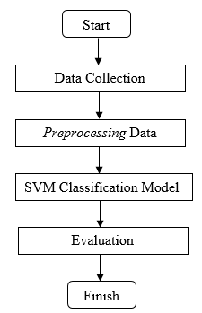
- Data Mining Method
Figure 1. Data mining flow

Based on Figure 1 it can be seen that the research to be carried out has several stages including:
- Data collection
Data collection conducted by the author is to conduct interviews and data collection directly at BMKG Cilacap from the process obtained data of 20623 starting from 2015-2017.
- Preprocessing data
  - Data preparation
For the first stage of data preprocessing is data preparation that is collecting all data in Microsoft Excel (.XLS) format. Data obtained from BMKG is still separated by year and month, and records are made hourly.
  - Handling of missing value
After the data has been checked and given information, the next step is handling the missing value. In the sea wave data there are several hours or even days without data or not recorded. Therefore, the missing data is handled by removing blank data for further analysis.
  - Normalizing data
The process of data normalization is to modify the values ​​in variables so that they can be measured on a general scale. In machine learning there are various forms of normalization. Some of the most common forms of normalization aim to change values ​​so that the number becomes 1.
  - Feature selection
The next stage is feature selection, generally in the analysis and research of data, not all attributes or features are used. At this stage the target attributes for the calculations are also determined.
  - Data classification
The process of data classification is to classify or classify data, so that they can see the report / results according to each group. Based on the data I got from BMKG Cilacap there are 4 levels of risk to the safety of shipping based on sea waves and wind speed.
  - Distribution of training sets and test sets
At this stage the data is divided into training data and testing data. Data is shared using features of the Python framework, and is divided based on the amount of data. Sharing data through Python can divide randomly so that it is considered to be closer to the machine learning approach that carries a random element.
- SVM Classification Model
Support Vector Machine (SVM) is the best method that can be used in classification problems. The SVM concept stems from the problem of classifying two classes so that it requires positive and negative training sets. SVM tries to find the best hyperplane (separator) to separate into these two classes (Pratama, A., Wihandika, R. C., and Ratnawati, D. E., 2018). At this stage the results of the distribution of training data and testing data that have been made previously will be modeled using the SVM algorithm. From a set of given training samples labeled either positive or negative, a maximum margin hyperplane splits the positive or negative training sample, as a result the distance between the margin and the hyperplane is maximized. If there exist no hyperplanes that can split the positive or negative samples, a SVM selects a hyperplane that splits the sample as austerely as possible, while still maximizing the distance to the nearest austerely split examples (Nayak, J., Naik, B., and Behera, H. S., 2015).

- Systems Development Method
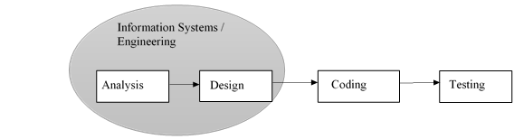
The system development method used in this study is Waterfall. The waterfall SDLC model is often called the sequential linear model or classic life cycle (Rossa, A. S., and Salahuddin, M., 2018).

Figure 2. Illustration of the waterfall model
The following are the steps that the Waterfall method must pass in the study:
- Software requirements analysis
The process of gathering needs is done intensively to specify software requirements so that software can be understood as what is needed by the user.
- The design
Software design is a multi-step process that focuses on the design of software programming including data structures, software architecture, interface representation, and coding procedures.
- Making program code
Designs must be translated into software programs. The result of this stage is a computer program in accordance with the design that was created at the design stage.
- Testing
Testing focuses on software in a logical and functional way and ensures that all parts have been tested.

RESULTS AND DISCUSSION

Data Mining Process
- Data collection
In this study the data used are Cilacap sea water data obtained by requesting directly and permission to the BMKG Cilacap office, this data consists of 22 features. In this data, there are 20623 data and the author uses only 9 features, namely, date, time, wind direction, wind speed, wave direction, minimum wave height, maximum wave height, average wave height, wavelength.
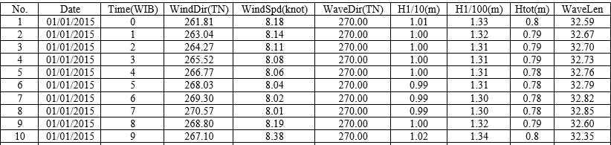

Figure 3. Samples of Cilacap Sea Waters data

- Preprocessing Data
1) Data preparation
At this stage the data obtained are still separated monthly and annually. To simplify the research process, all data is combined first into one document. All data that has been merged and initially with the XLS extension is then converted to CSV file.
2) Handling of missing value
At this stage missing values will be performed as the preprocessing stage. Missing values in a data can affect the results of accuracy, therefore handling of missing values is performed. Because in this dataset there are many missing data values. Then the removal of data with missing values is performed in Microsoft Excel.
3) Normalization
The normalization process is to modify the values in a variable so that we can measure it on a general scale. In the process of normalizing the date, time, and target attributes do not participate normalized.
4) Feature selection
At the feature selection stage, the target attribute will be determined to perform the calculation. With this in mind, selecting features can reduce many of the redundant features that are less needed that can lead to a slower process of training models and reduce accuracy.
5) Data classification
The process of data classification is to classify or classify data, so that they can see the report / results according to each group. Based on the data that I got from BMKG Cilacap there are 4 levels of risk to the safety of shipping based on sea waves and wind speed. Following the risk level table:
Table 1. Risk Level
Risk level based | Very low | Low | Medium | High
wind speed | <7 knot | 7-10 knot | 10-15 knot |  | >15 knot
Wave height | <0.5 m | 0.5-1.0 m | 10-1.25 m |  | >1.25 m

Based on table 1 Level of risk, then the data is classified in Microsoft Excel and creates a new variable named target. The following are the results of data classification based on risk level:
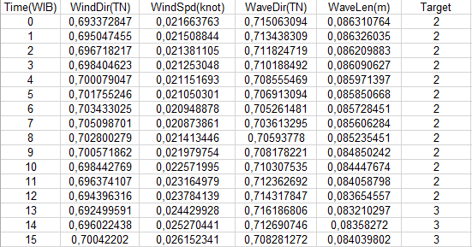

Figure 4. Results of data classification
In Figure 4 the data are grouped according to table 1 the level of risk by creating a new variable named target. In the target variable there are numbers 3, 2, 1 and 0. Number 3 indicates high risk, number 2 moderate risk, number 1 low risk and number 0 very low risk.
6) Distribution of training and testing data
Training sets are used to create machine learning models, while testing sets are used to test performance and correctness in data mining models. The comparison between training and testing data is 7: 3 or it can be said that 70% of the total data is used for training, while 30% is used for testing.

- Model Support Vector Machine (SVM)
After dividing the data into testing and training sets. Next is implementing the model in the training data. Scikit-Learn is the libraries needed for classification in the data analysis process. To create an SVM model, the SVM library from Scikit-Learn must be imported first. Because we do the classification, the author uses the support vector classification class written with "SVC" in the library of Scikit-Learn, the "fit" method of the SVC class is called to practice the algorithm in training data.
- Evaluation
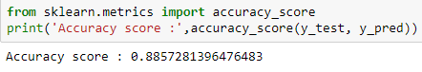
- Accuracy

Figure 5. Process and accuracy results
Accuracy can be calculated by comparing test data and predictive value. The picture above is the result of the performance of the dataset which produces an accuracy of 88%.
- Precision and Recall
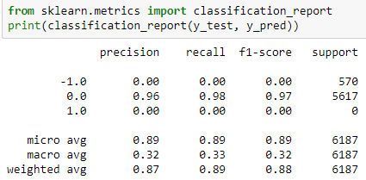

Figure 6. Process and results of precision, recall
Based on Figure 6 is the result of the performance of the dataset that produces a precision of 87% and recall 89%.

Analysis of Results
- Functional Requirements
Functional requirements are system service statements that must be provided, how the system reacts to certain processes and how the system behaves in certain situations. Functional requirements in system development are as follows:
- Input Requirements
Input needs or input needed to meet the needs of the implementation of this system is the main page that serves to operate the system by starting the determination and input time of time and date.
- Process Requirements
The process of determining the schedule to determine the fishing sailing schedule based on sea waves and wind speed.
- Output Needs
In the form of output or the results of determining the fisherman's sailing schedule after the process needs to be done.
- Interface Requirements
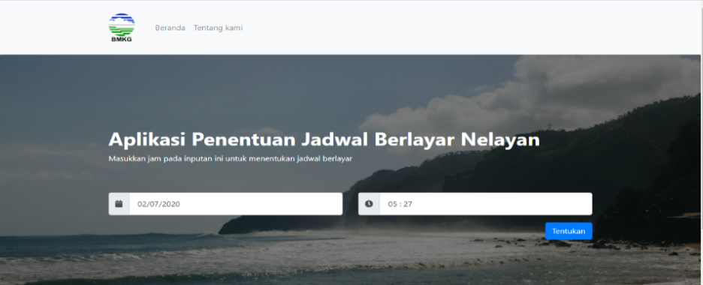
There are a number of pages on the system, i.e. interface (homepage) and output, about-interface page.

Figure 7. The main page of the website
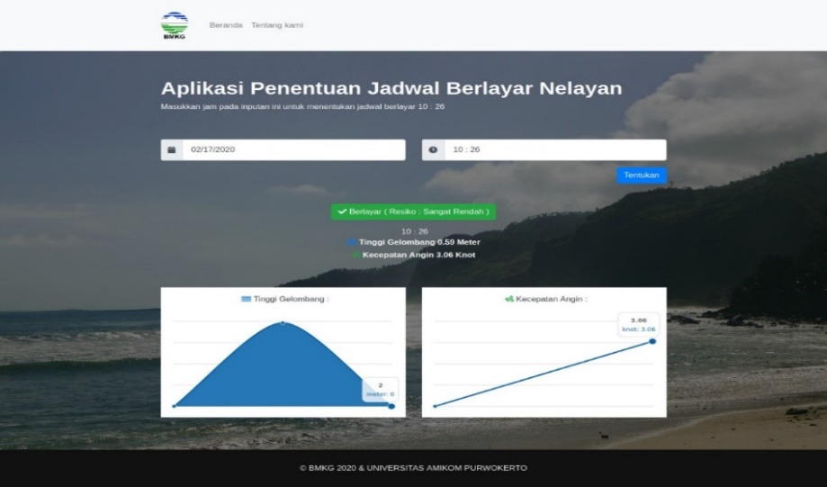
On the main page of the website there is a date and time field for inputting the desired date and time, then the specify button to see the results. Then there is the homepage link to return to the start page and a link about us which contains information about the application.

Figure 8. Main page after output exits
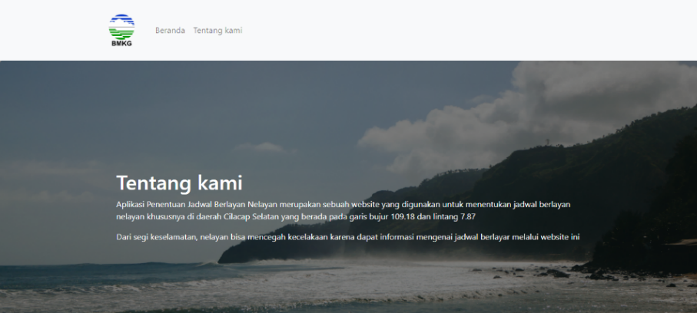
In Figure 8 is the main page to see the results after inputting the date and time. Then sail / no information appears and there are risk categories (very low, low, medium and high) based on sea waves and wind speed. There are graphs to illustrate the wave height and wind speed.

Figure 9. Pages about us
On the page about us contains information about the application of determining the fishing sailing schedule which is at longitude 109.18 and latitude 7.87.

CONCLUSIONS AND RECOMMENDATIONS
Based on the results of the research that has been done, the following conclusions can be drawn that This research has succeeded in classifying data based on 4 levels of risk. This study has successfully predicted using the Support Vector Machine algorithm with the results of the performance of the dataset that produces an accuracy of 88%, precision 87% and recall 89%. This research has succeeded in creating a website-based system for determining fishermen sailing schedules based on sea waves using data mining methods. The results of black box testing produce functionality from applications that have been built that the application has been successfully running in accordance with their respective functions.

acknowledgement
Our thanks to Universitas Amikom Purwokerto, Indonesia for supporting of our publishing paper.

References/Bibliography
The Ramdhan, M., and Arifin, T. (2013). The Application of the geographic information system in a comprehensive assessment of Indonesian ocean. Geometica Scientific Journal, 19(2), 141-146
Ministry of Marine a Fisheries (2019). Official Ceremony of Bale Kusuka Kab. Cilacap. Taken from https://kkp.go.id/djpt/ppscilacap/artikel/9937-peresmian-bale-kusuma-kab-cilacap, accessed on 20 Januari 2020
Meteorological, Climatology, and Geophysical Agences (2020). Duty and Function. Taken from https://www.bmkg.go.id/profil/?p=tugas-fungsi, accessed on 5 Januari 2020.
Kusrini., and Luthfi, E. T. (2009). Data Mining Algorithms. Yogyakarta: Andi.
Wei, C. C. (2018). Nearshore wave predictions using data mining techniques during typhoons: A case study near Taiwan’s northeastern coast. Energies, 11(1). https://doi.org/10.3390/en11010011
Elbisy, M. S. (2015). Sea Wave Parameters Prediction by Support Vector Machine Using a Genetic Algorithm. Journal of Coastal Research, 314(October), 892–899. https://doi.org/10.2112/jcoastres-d-13-00087.1
Pratama, A., Wihandika, R. C., and Ratnawati, D. E. (2018). Implementation of the Algorithm Support Vector Machine (SVM) Algorithm for a predictive dead time. Pengembangan Teknologi Informasi dan Ilmu Komputer, 2(4), 1704-1708.
Nayak, J., Naik, B., and Behera, H. S. (2015). A Comprehensive Survey on Support Vector Machine in Data Mining Tasks: Applications & Challenges. International Journal of Database Theory and Application, 8(1), 169–186. https://doi.org/10.14257/ijdta.2015.8.1.18
Rossa, A. S., and Shalahudidin, M. (2018). Stuctured, oriented software engineering. Bandung: Informatika.

